Batch Script - Quick Guide
https://www.tutorialspoint.com/batch_script/batch_script_quick_guide.htm
Copyright © tutorialspoint.com

Batch Script - Overview
Batch Script is incorporated to automate command sequences which are repetitive in nature. Scripting is a way by which one can alleviate this necessity by automating these command sequences in order to make one’s life at the shell easier and more productive. In most organizations, Batch Script is incorporated in some way or the other to automate stuff.
Some of the features of Batch Script are −
- Can read inputs from users so that it can be processed further.
- Has control structures such as for, if, while, switch for better automating and scripting.
- Supports advanced features such as Functions and Arrays.
- Supports regular expressions.
- Can include other programming codes such as Perl.
Some of the common uses of Batch Script are −
- Setting up servers for different purposes.
- Automating housekeeping activities such as deleting unwanted files or log files.
- Automating the deployment of applications from one environment to another.
- Installing programs on various machines at once.
Batch scripts are stored in simple text files containing lines with commands that get executed in sequence, one after the other. These files have the special extension BAT or CMD. Files of this type are recognized and executed through an interface sometimescalledashell
provided by a system file called the command interpreter. On Windows systems, this interpreter is known as cmd.exe.
Running a batch file is a simple matter of just clicking on it. Batch files can also be run in a command prompt or the Start-Run line. In such case, the full path name must be used unless the file's path is in the path environment. Following is a simple example of a Batch Script. This Batch Script when run deletes all files in the current directory.
:: Deletes All files in the Current Directory With Prompts and Warnings
::(Hidden, System, and Read-Only Files are Not Affected)
:: @ECHO OFF
DEL . DR

Batch Script - Environment
This chapter explains the environment related to Batch Script.

Writing and Executing
Typically, to create a batch file, notepad is used. This is the simplest tool for creation of batch files. Next is the execution environment for the batch scripts. On Windows systems, this is done via the command prompt or cmd.exe. All batch files are run in this environment.
Following are the different ways to launch cmd.exe −
Method 1 − Go to C:\Windows\System32 and double click on the cmd file.
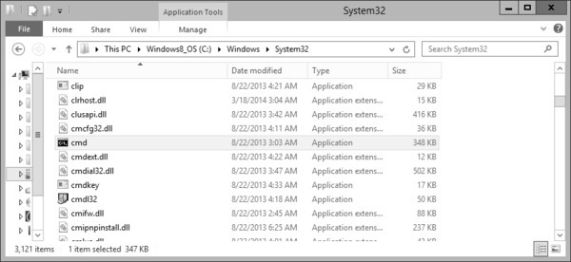
Method 2 − Via the run command – The following snapshot shows to find the command promptcmd.exe
on Windows server 2012.
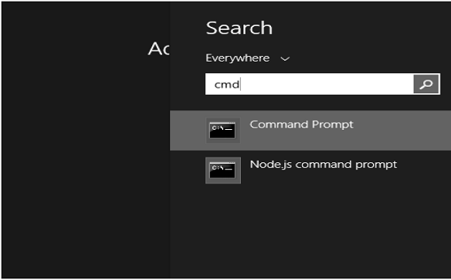
Once the cmd.exe is launched, you will be presented with the following screen. This will be your environment for executing your batch scripts.
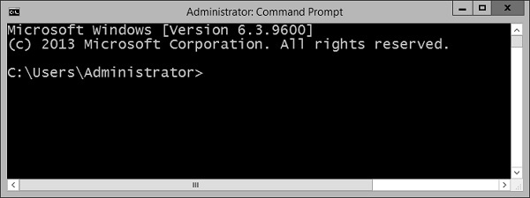

Environment Variables
In order to run batch files from the command prompt, you either need to go to the location to where the batch file is stored or alternatively you can enter the file location in the path environment variable. Thus assuming that the batch file is stored in the location C:\Application\bin, you would need to follow these instructions for the PATH variable inclusion.
OS | Output
Windows | Append the String; C:\Application\bin to the end of the system variable PATH.

Batch Script - Commands
In this chapter, we will look at some of the frequently used batch commands.
S.No | Commands & Description
1 | VER  This batch command shows the version of MS-DOS you are using.
2 | ASSOC  This is a batch command that associates an extension with a file type FTYPE
, displays existing associations, or deletes an association.
3 | CD  This batch command helps in making changes to a different directory, or displays the current directory.
4 | CLS  This batch command clears the screen.
5 | COPY  This batch command is used for copying files from one location to the other.
6 | DEL  This batch command deletes files and not directories.
7 | DIR  This batch command lists the contents of a directory.
8 | DATE  This batch command help to find the system date.
9 | ECHO  This batch command displays messages, or turns command echoing on or off.
10 | EXIT  This batch command exits the DOS console.
11 | MD  This batch command creates a new directory in the current location.
12 | MOVE  This batch command moves files or directories between directories.
13 | PATH  This batch command displays or sets the path variable.
14 | PAUSE  This batch command prompts the user and waits for a line of input to be entered.
15 | PROMPT  This batch command can be used to change or reset the cmd.exe prompt.
16 | RD  This batch command removes directories, but the directories need to be empty before they can be removed.
17 | REN  Renames files and directories
18 | REM  This batch command is used for remarks in batch files, preventing the content of the remark from being executed.
19 | START  This batch command starts a program in new window, or opens a document.
20 | TIME  This batch command sets or displays the time.
21 | TYPE  This batch command prints the content of a file or files to the output.
22 | VOL  This batch command displays the volume labels.
23 | ATTRIB  Displays or sets the attributes of the files in the curret directory
24 | CHKDSK  This batch command checks the disk for any problems.
25 | CHOICE  This batch command provides a list of options to the user.
26 | CMD  This batch command invokes another instance of command prompt.
27 | COMP  This batch command compares 2 files based on the file size.
28 | CONVERT  This batch command converts a volume from FAT16 or FAT32 file system to NTFS file system.
29 | DRIVERQUERY  This batch command shows all installed device drivers and their properties.
30 | EXPAND  This batch command extracts files from compressed .cab cabinet files.
31 | FIND  This batch command searches for a string in files or input, outputting matching lines.
32 | FORMAT  This batch command formats a disk to use Windows-supported file system such as FAT, FAT32 or NTFS, thereby overwriting the previous content of the disk.
33 | HELP  This batch command shows the list of Windows-supplied commands.
34 | IPCONFIG  This batch command displays Windows IP Configuration. Shows configuration by connection and the name of that connection.
35 | LABEL  This batch command adds, sets or removes a disk label.
36 | MORE  This batch command displays the contents of a file or files, one screen at a time.
37 | NET  Provides various network services, depending on the command used.
38 | PING  This batch command sends ICMP/IP "echo" packets over the network to the designated address.
39 | SHUTDOWN  This batch command shuts down a computer, or logs off the current user.
40 | SORT  This batch command takes the input from a source file and sorts its contents alphabetically, from A to Z or Z to A. It prints the output on the console.
41 | SUBST  This batch command assigns a drive letter to a local folder, displays current assignments, or removes an assignment.
42 | SYSTEMINFO  This batch command shows configuration of a computer and its operating system.
43 | TASKKILL  This batch command ends one or more tasks.
44 | TASKLIST  This batch command lists tasks, including task name and process id PID
.
45 | XCOPY  This batch command copies files and directories in a more advanced way.
46 | TREE  This batch command displays a tree of all subdirectories of the current directory to any level of recursion or depth.
47 | FC  This batch command lists the actual differences between two files.
48 | DISKPART  This batch command shows and configures the properties of disk partitions.
49 | TITLE  This batch command sets the title displayed in the console window.
50 | SET  Displays the list of environment variables on the current system.

Batch Script - Files
In this chapter, we will learn how to create, save, execute, and modify batch files.

Creating Batch Files
Batch files are normally created in notepad. Hence the simplest way is to open notepad and enter the commands required for the script. For this exercise, open notepad and enter the following statements.
:: Deletes All files in the Current Directory With Prompts and Warnings
::(Hidden, System, and Read-Only Files are Not Affected)
::
@ECHO OFF
DEL .
DR

Saving Batch Files
After your batch file is created, the next step is to save your batch file. Batch files have the extension of either .bat or .cmd. Some general rules to keep in mind when naming batch files −
- Try to avoid spaces when naming batch files, it sometime creates issues when they are called from other scripts.
- Don’t name them after common batch files which are available in the system such as ping.cmd.
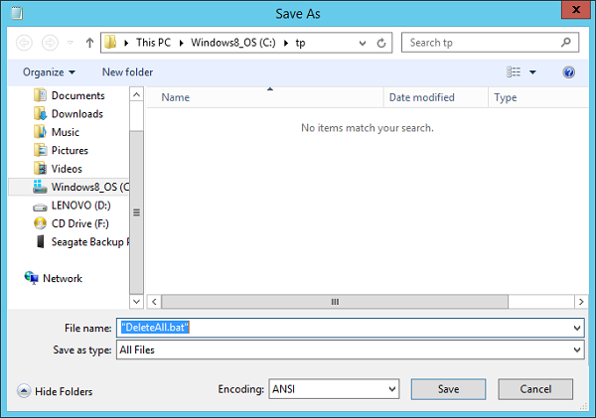
The above screenshot shows how to save the batch file. When saving your batch file a few points to keep in mind.
- Remember to put the .bat or .cmd at the end of the file name.
- Choose the “Save as type” option as “All Files”.
- Put the entire file name in quotes “”.

Executing Batch Files
Following are the steps to execute a batch file −
- Step 1 − Open the command prompt cmd.exe
- .
- Step 2 − Go to the location where the .bat or .cmd file is stored.
- Step 3 − Write the name of the file as shown in the following image and press the Enter button to execute the batch file.
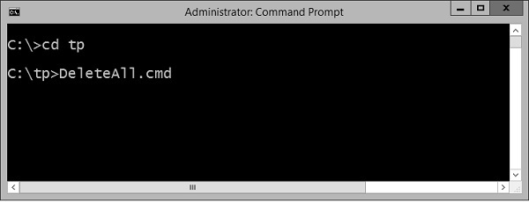

Modifying Batch Files
Following are the steps for modifying an existing batch file.
- Step 1 − Open windows explorer.
- Step 2 − Go to the location where the .bat or .cmd file is stored.
- Step 3 − Right-click the file and choose the “Edit” option from the context menu. The file will open in Notepad for further editing.
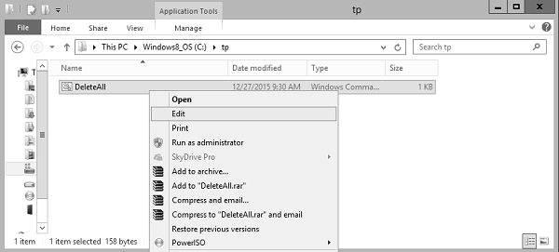

Batch Script - Syntax
Normally, the first line in a batch file often consists of the following command.

ECHO Command
@echo off
By default, a batch file will display its command as it runs. The purpose of this first command is to turn off this display. The command "echo off" turns off the display for the whole script, except for the "echo off" command itself. The "at" sign "@" in front makes the command apply to itself as well.

Documentation
Very often batch files also contains lines that start with the "Rem" command. This is a way to enter comments and documentation. The computer ignores anything on a line following Rem. For batch files with increasing amount of complexity, this is often a good idea to have comments.

First Batch Script Program
Let’s construct our simple first batch script program. Open notepad and enter the following lines of code. Save the file as “List.cmd”.
The code does the following −
- Uses the echo off command to ensure that the commands are not shown when the code is executed.
- The Rem command is used to add a comment to say what exactly this batch file does.
- The dir command is used to take the contents of the location C:\Program Files.
- The ‘>’ command is used to redirect the output to the file C:\lists.txt.
- Finally, the echo command is used to tell the user that the operation is completed.
@echo off
Rem This is for listing down all the files in the directory Program files
dir "C:\Program Files" > C:\lists.txt
echo "The program has completed"
When the above command is executed, the names of the files in C:\Program Files will be sent to the file C:\Lists.txt and in the command prompt the message “The program has completed” will be displayed.

Batch Script - Variables
There are two types of variables in batch files. One is for parameters which can be passed when the batch file is called and the other is done via the set command.

Command Line Arguments
Batch scripts support the concept of command line arguments wherein arguments can be passed to the batch file when invoked. The arguments can be called from the batch files through the variables %1, %2, %3, and so on.
The following example shows a batch file which accepts 3 command line arguments and echo’s them to the command line screen.
@echo off
echo %1
echo %2
echo %3
If the above batch script is stored in a file called test.bat and we were to run the batch as
Test.bat 1 2 3
Following is a screenshot of how this would look in the command prompt when the batch file is executed.
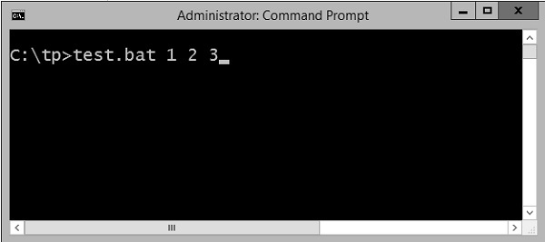
The above command produces the following output.
1
2
3
If we were to run the batch as
Example 1 2 3 4
The output would still remain the same as above. However, the fourth parameter would be ignored.

Set Command
The other way in which variables can be initialized is via the ‘set’ command. Following is the syntax of the set command.

Syntax
set /A variable-name=value
where,
- variable-name is the name of the variable you want to set.
- value is the value which needs to be set against the variable.
- /A – This switch is used if the value needs to be numeric in nature.
The following example shows a simple way the set command can be used.

Example
@echo off
set message=Hello World
echo %message%
- In the above code snippet, a variable called message is defined and set with the value of "Hello World".
- To display the value of the variable, note that the variable needs to be enclosed in the % sign.

Output
The above command produces the following output.
Hello World

Working with Numeric Values
In batch script, it is also possible to define a variable to hold a numeric value. This can be done by using the /A switch.
The following code shows a simple way in which numeric values can be set with the /A switch.
@echo off
SET /A a = 5
SET /A b = 10
SET /A c = %a% + %b%
echo %c%
- We are first setting the value of 2 variables, a and b to 5 and 10 respectively.
- We are adding those values and storing in the variable c.
- Finally, we are displaying the value of the variable c.
The output of the above program would be 15.
All of the arithmetic operators work in batch files. The following example shows arithmetic operators can be used in batch files.
@echo off
SET /A a = 5
SET /A b = 10
SET /A c = %a% + %b%
echo %c%
SET /A c = %a% - %b%
echo %c%
SET /A c = %b% / %a%
echo %c%
SET /A c = %b% * %a%
echo %c%
The above command produces the following output.
15
-5
2
50

Local vs Global Variables
In any programming language, there is an option to mark variables as having some sort of scope, i.e. the section of code on which they can be accessed. Normally, variable having a global scope can be accessed anywhere from a program whereas local scoped variables have a defined boundary in which they can be accessed.
DOS scripting also has a definition for locally and globally scoped variables. By default, variables are global to your entire command prompt session. Call the SETLOCAL command to make variables local to the scope of your script. After calling SETLOCAL, any variable assignments revert upon calling ENDLOCAL, calling EXIT, or when execution reaches the end of file EOF
in your script. The following example shows the difference when local and global variables are set in the script.

Example
@echo off
set globalvar = 5
SETLOCAL
set var = 13145
set /A var = %var% + 5
echo %var%
echo %globalvar%
ENDLOCAL
Few key things to note about the above program.
- The ‘globalvar’ is defined with a global scope and is available throughout the entire script.
- The ‘var‘ variable is defined in a local scope because it is enclosed between a ‘SETLOCAL’ and ‘ENDLOCAL’ block. Hence, this variable will be destroyed as soon the ‘ENDLOCAL’ statement is executed.

Output
The above command produces the following output.
13150
5
You will notice that the command echo %var% will not yield anything because after the ENDLOCAL statement, the ‘var’ variable will no longer exist.

Working with Environment Variables
If you have variables that would be used across batch files, then it is always preferable to use environment variables. Once the environment variable is defined, it can be accessed via the % sign. The following example shows how to see the JAVA_HOME defined on a system. The JAVA_HOME variable is a key component that is normally used by a wide variety of applications.
@echo off
echo %JAVA_HOME%
The output would show the JAVA_HOME directory which would depend from system to system. Following is an example of an output.
C:\Atlassian\Bitbucket\4.0.1\jre

Batch Script - Comments
It’s always a good practice to add comments or documentation for the scripts which are created. This is required for maintenance of the scripts to understand what the script actually does.
For example, consider the following piece of code which has no form of comments. If any average person who has not developed the following script tries to understand the script, it would take a lot of time for that person to understand what the script actually does.
ECHO OFF
IF NOT "%OS%"=="Windows_NT" GOTO Syntax
ECHO.%* | FIND "?" >NUL
IF NOT ERRORLEVEL 1 GOTO Syntax
IF NOT [%2]==[] GOTO Syntax
SETLOCAL
SET WSS=
IF NOT [%1]==[] FOR /F "tokens = 1 delims = \ " %%A IN ('ECHO.%~1') DO SET WSS = %%A
FOR /F "tokens = 1 delims = \ " %%a IN ('NET VIEW ^| FIND /I "\\%WSS%"') DO FOR /F
"tokens = 1 delims = " %%A IN ('NBTSTAT -a %%a ^| FIND /I /V "%%a" ^| FIND "<03>"')
DO ECHO.%%a %%A
ENDLOCAL
GOTO:EOF
ECHO Display logged on users and their workstations.
ECHO Usage: ACTUSR [ filter ]
IF "%OS%"=="Windows_NT" ECHO Where: filter is the first part
of the computer name^(s^) to be displayed

Comments Using the Rem Statement
There are two ways to create comments in Batch Script; one is via the Rem command. Any text which follows the Rem statement will be treated as comments and will not be executed. Following is the general syntax of this statement.

Syntax
Rem Remarks
where ‘Remarks’ is the comments which needs to be added.
The following example shows a simple way the Rem command can be used.

Example
@echo off
Rem This program just displays Hello World
set message=Hello World
echo %message%

Output
The above command produces the following output. You will notice that the line with the Rem statement will not be executed.
Hello World

Comments Using the :: Statement
The other way to create comments in Batch Script is via the :: command. Any text which follows the :: statement will be treated as comments and will not be executed. Following is the general syntax of this statement.

Syntax
:: Remarks
where ‘Remarks’ is the comment which needs to be added.
The following example shows a simple way the Rem command can be used.

Example
@echo off
:: This program just displays Hello World
set message = Hello World
echo %message%

Output
The above command produces the following output. You will notice that the line with the :: statement will not be executed.
Hello World
Note − If you have too many lines of Rem, it could slow down the code, because in the end each line of code in the batch file still needs to be executed.
Let’s look at the example of the large script we saw at the beginning of this topic and see how it looks when documentation is added to it.
::===============================================================
:: The below example is used to find computer and logged on users
::
::===============================================================
ECHO OFF
:: Windows version check
IF NOT "%OS%"=="Windows_NT" GOTO Syntax
ECHO.%* | FIND "?" >NUL
:: Command line parameter check
IF NOT ERRORLEVEL 1 GOTO Syntax
IF NOT [%2]==[] GOTO Syntax
:: Keep variable local
SETLOCAL
:: Initialize variable
SET WSS=
:: Parse command line parameter
IF NOT [%1]==[] FOR /F "tokens = 1 delims = \ " %%A IN ('ECHO.%~1') DO SET WSS = %%A
:: Use NET VIEW and NBTSTAT to find computers and logged on users
FOR /F "tokens = 1 delims = \ " %%a IN ('NET VIEW ^| FIND /I "\\%WSS%"') DO FOR /F
"tokens = 1 delims = " %%A IN ('NBTSTAT -a %%a ^| FIND /I /V "%%a" ^| FIND
"<03>"') DO ECHO.%%a %%A
:: Done
ENDLOCAL
GOTO:EOF
:Syntax
ECHO Display logged on users and their workstations.
ECHO Usage: ACTUSR [ filter ]
IF "%OS%"=="Windows_NT" ECHO Where: filter is the first part of the
computer name^(s^) to be displayed
You can now see that the code has become more understandable to users who have not developed the code and hence is more maintainable.

Batch Script - Strings
In DOS, a string is an ordered collection of characters, such as "Hello, World!".
S.No | Strings & Description
1 | Create String  A string can be created in DOS in the following way.
2 | Empty String  Empty String
3 | String Interpolation  String interpolation is a way to construct a new String value from a mix of constants, variables, literals, and expressions by including their values inside a string literal.
4 | String Concatenation  You can use the set operator to concatenate two strings or a string and a character, or two characters. Following is a simple example which shows how to use string concatenation.
5 | String length  In DOS scripting, there is no length function defined for finding the length of a string. There are custom-defined functions which can be used for the same. Following is an example of a custom-defined function for seeing the length of a string.
6 | toInt  A variable which has been set as string using the set variable can be converted to an integer using the /A switch which is using the set variable. The following example shows how this can be accomplished.
7 | Align Right  This used to align text to the right, which is normally used to improve readability of number columns.
8 | Left String  This is used to extract characters from the beginning of a string.
9 | Mid String  This is used to extract a substring via the position of the characters in the string.
10 | Remove  The string substitution feature can also be used to remove a substring from another string.
11 | Remove Both Ends  This is used to remove the first and the last character of a string.
12 | Remove All Spaces  This is used to remove all spaces in a string via substitution.
13 | Replace a String  To replace a substring with another string use the string substitution feature.
14 | Right String  This is used to extract characters from the end of a string.

Batch Script - Arrays
Arrays are not specifically defined as a type in Batch Script but can be implemented. The following things need to be noted when arrays are implemented in Batch Script.
- Each element of the array needs to be defined with the set command.
- The ‘for’ loop would be required to iterate through the values of the array.

Creating an Array
An array is created by using the following set command.
set a[0]=1
Where 0 is the index of the array and 1 is the value assigned to the first element of the array.
Another way to implement arrays is to define a list of values and iterate through the list of values. The following example show how this can be implemented.

Example
@echo off
set list = 1 2 3 4
(for %%a in (%list%) do (
echo %%a
))

Output
The above command produces the following output.
1
2
3
4

Accessing Arrays
You can retrieve a value from the array by using subscript syntax, passing the index of the value you want to retrieve within square brackets immediately after the name of the array.

Example
@echo off
set a[0]=1
echo %a[0]%
In this example, the index starts from 0 which means the first element can be accessed using index as 0, the second element can be accessed using index as 1 and so on. Let's check the following example to create, initialize and access arrays −
@echo off
set a[0] = 1
set a[1] = 2
set a[2] = 3
echo The first element of the array is %a[0]%
echo The second element of the array is %a[1]%
echo The third element of the array is %a[2]%
The above command produces the following output.
The first element of the array is 1
The second element of the array is 2
The third element of the array is 3

Modifying an Array
To add an element to the end of the array, you can use the set element along with the last index of the array element.

Example
@echo off
set a[0] = 1
set a[1] = 2
set a[2] = 3
Rem Adding an element at the end of an array
Set a[3] = 4
echo The last element of the array is %a[3]%
The above command produces the following output.
The last element of the array is 4
You can modify an existing element of an Array by assigning a new value at a given index as shown in the following example −
@echo off
set a[0] = 1
set a[1] = 2
set a[2] = 3
Rem Setting the new value for the second element of the array
Set a[1] = 5
echo The new value of the second element of the array is %a[1]%
The above command produces the following output.
The new value of the second element of the array is 5

Iterating Over an Array
Iterating over an array is achieved by using the ‘for’ loop and going through each element of the array. The following example shows a simple way that an array can be implemented.
@echo off
setlocal enabledelayedexpansion
set topic[0] = comments
set topic[1] = variables
set topic[2] = Arrays
set topic[3] = Decision making
set topic[4] = Time and date
set topic[5] = Operators

for /l %%n in (0,1,5) do (
echo !topic[%%n]!
)
Following things need to be noted about the above program −
- Each element of the array needs to be specifically defined using the set command.
- The ‘for’ loop with the /L parameter for moving through ranges is used to iterate through the array.

Output
The above command produces the following output.
Comments
variables
Arrays
Decision making
Time and date
Operators

Length of an Array
The length of an array is done by iterating over the list of values in the array since there is no direct function to determine the number of elements in an array.
@echo off
set Arr[0] = 1
set Arr[1] = 2
set Arr[2] = 3
set Arr[3] = 4
set "x = 0"
:SymLoop

if defined Arr[%x%] (
call echo %%Arr[%x%]%%
set /a "x+=1"
GOTO :SymLoop
)
echo "The length of the array is" %x%

Output
Output The above command produces the following output.
The length of the array is 4

Creating Structures in Arrays
Structures can also be implemented in batch files using a little bit of an extra coding for implementation. The following example shows how this can be achieved.

Example
@echo off
set len = 3
set obj[0].Name = Joe
set obj[0].ID = 1
set obj[1].Name = Mark
set obj[1].ID = 2
set obj[2].Name = Mohan
set obj[2].ID = 3
set i = 0
:loop

if %i% equ %len% goto :eof
set cur.Name=
set cur.ID=

for /f "usebackq delims==.tokens=1-3" %%j in (`set obj[%i%]`) do (
set cur.%%k=%%l
)
echo Name = %cur.Name%
echo Value = %cur.ID%
set /a i = %i%+1
goto loop
The following key things need to be noted about the above code.
- Each variable defined using the set command has 2 values associated with each index of the array.
- The variable i is set to 0 so that we can loop through the structure will the length of the array which is 3.
- We always check for the condition on whether the value of i is equal to the value of len and if not, we loop through the code.
- We are able to access each element of the structure using the obj[%i%] notation.

Output
The above command produces the following output.
Name = Joe
Value = 1
Name = Mark
Value = 2
Name = Mohan
Value = 3

Batch Script - Decision Making
Decision-making structures require that the programmer specify one or more conditions to be evaluated or tested by the program, along with a statement or statements to be executed if the condition is determined to be true, and optionally, other statements to be executed if the condition is determined to be false.
S.No | Strings & Description
1 | If Statement  The first decision-making statement is the ‘if’ statement.
2 | If/else Statement  The next decision making statement is the If/else statement. Following is the general form of this statement.
3 | Nested If Statements  Sometimes, there is a requirement to have multiple ‘if’ statement embedded inside each other. Following is the general form of this statement.

Batch Script - Operators
An operator is a symbol that tells the compiler to perform specific mathematical or logical manipulations.
In batch script, the following types of operators are possible.
- Arithmetic operators
- Relational operators
- Logical operators
- Assignment operators
- Bitwise operators

Arithmetic Operators
Batch script language supports the normal Arithmetic operators as any language. Following are the Arithmetic operators available.
Show Example
Operator | Description | Example
+ | Addition of two operands | 1 + 2 will give 3
− | Subtracts second operand from the first | 2 − 1 will give 1
* | Multiplication of both operands | 2 * 2 will give 4
/ | Division of the numerator by the denominator | 3 / 2 will give 1.5
% | Modulus operator and remainder of after an integer/float division | 3 % 2 will give 1

Relational Operators
Relational operators allow of the comparison of objects. Below are the relational operators available.
Show Example
Operator | Description | Example
EQU | Tests the equality between two objects | 2 EQU 2 will give true
NEQ | Tests the difference between two objects | 3 NEQ 2 will give true
LSS | Checks to see if the left object is less than the right operand | 2 LSS 3 will give true
LEQ | Checks to see if the left object is less than or equal to the right operand | 2 LEQ 3 will give true
GTR | Checks to see if the left object is greater than the right operand | 3 GTR 2 will give true
GEQ | Checks to see if the left object is greater than or equal to the right operand | 3 GEQ 2 will give true

Logical Operators
Logical operators are used to evaluate Boolean expressions. Following are the logical operators available.
The batch language is equipped with a full set of Boolean logic operators like AND, OR, XOR, but only for binary numbers. Neither are there any values for TRUE or FALSE. The only logical operator available for conditions is the NOT operator.
Show Example
Operator | Description
AND | This is the logical “and” operator
OR | This is the logical “or” operator
NOT | This is the logical “not” operator

Assignment Operators
Batch Script language also provides assignment operators. Following are the assignment operators available.
Show Example
Operator | Description | Example
+= | This adds right operand to the left operand and assigns the result to left operand | Set /A a = 5  a += 3  Output will be 8
-= | This subtracts the right operand from the left operand and assigns the result to the left operand | Set /A a = 5  a -= 3  Output will be 2
*= | This multiplies the right operand with the left operand and assigns the result to the left operand | Set /A a = 5  a *= 3  Output will be 15
/= | This divides the left operand with the right operand and assigns the result to the left operand | Set /A a = 6  a/ = 3  Output will be 2
%= | This takes modulus using two operands and assigns the result to the left operand | Set /A a = 5  a% = 3  Output will be 2

Bitwise Operators
Bitwise operators are also possible in batch script. Following are the operators available.
Show Example
Operator | Description
& | This is the bitwise “and” operator
| | This is the bitwise “or” operator
^ | This is the bitwise “xor” or Exclusive or operator
Following is the truth table showcasing these operators.
p | q | p & q | p | q | p ^ q
0 | 0 | 0 | 0 | 0
0 | 1 | 0 | 1 | 1
1 | 1 | 1 | 1 | 0
1 | 0 | 0 | 1 | 1

Batch Script - DATE and TIME
The date and time in DOS Scripting have the following two basic commands for retrieving the date and time of the system.

DATE
This command gets the system date.

Syntax
DATE

Example
@echo off
echo %DATE%

Output
The current date will be displayed in the command prompt. For example,
Mon 12/28/2015

TIME
This command sets or displays the time.

Syntax
TIME

Example
@echo off
echo %TIME%

Output
The current system time will be displayed. For example,
22:06:52.87
Following are some implementations which can be used to get the date and time in different formats.

Date in Format Year-Month-Day

Example
@echo off
echo/Today is: %year%-%month%-%day%
goto :EOF
setlocal ENABLEEXTENSIONS
set t = 2&if "%date%z" LSS "A" set t = 1

for /f "skip=1 tokens = 2-4 delims = (-)" %%a in ('echo/^|date') do (
for /f "tokens = %t%-4 delims=.-/ " %%d in ('date/t') do (
set %%a=%%d&set %%b=%%e&set %%c=%%f))
endlocal&set %1=%yy%&set %2=%mm%&set %3=%dd%&goto :EOF

Output
The above command produces the following output.
Today is: 2015-12-30

Batch Script - Input / Output
There are three universal “files” for keyboard input, printing text on the screen and printing errors on the screen. The “Standard In” file, known as stdin, contains the input to the program/script. The “Standard Out” file, known as stdout, is used to write output for display on the screen. Finally, the “Standard Err” file, known as stderr, contains any error messages for display on the screen.
Each of these three standard files, otherwise known as the standard streams, are referenced using the numbers 0, 1, and 2. Stdin is file 0, stdout is file 1, and stderr is file 2.

Redirecting Output StdoutandStderr
One common practice in batch files is sending the output of a program to a log file. The > operator sends, or redirects, stdout or stderr to another file. The following example shows how this can be done.
Dir C:\ > list.txt
In the above example, the stdout of the command Dir C:\ is redirected to the file list.txt.
If you append the number 2 to the redirection filter, then it would redirect the stderr to the file lists.txt.
Dir C:\ 2> list.txt
One can even combine the stdout and stderr streams using the file number and the ‘&’ prefix. Following is an example.
DIR C:\ > lists.txt 2>&1

Suppressing Program Output
The pseudo file NUL is used to discard any output from a program. The following example shows that the output of the command DIR is discarded by sending the output to NUL.
Dir C:\ > NUL

Stdin
To work with the Stdin, you have to use a workaround to achieve this. This can be done by redirecting the command prompt’s own stdin, called CON.
The following example shows how you can redirect the output to a file called lists.txt. After you execute the below command, the command prompt will take all the input entered by user till it gets an EOF character. Later, it sends all the input to the file lists.txt.
TYPE CON > lists.txt

Batch Script - Return Code
By default when a command line execution is completed it should either return zero when execution succeeds or non-zero when execution fails. When a batch script returns a non-zero value after the execution fails, the non-zero value will indicate what is the error number. We will then use the error number to determine what the error is about and resolve it accordingly.
Following are the common exit code and their description.
Error Code | Description
0 | Program successfully completed.
1 | Incorrect function. Indicates that Action has attempted to execute non-recognized command in Windows command prompt cmd.exe.
2 | The system cannot find the file specified. Indicates that the file cannot be found in specified location.
3 | The system cannot find the path specified. Indicates that the specified path cannot be found.
5 | Access is denied. Indicates that user has no access right to specified resource.
9009  0x2331 | Program is not recognized as an internal or external command, operable program or batch file. Indicates that command, application name or path has been misspelled when configuring the Action.
221225495  0xC0000017  -1073741801 | Not enough virtual memory is available.  It indicates that Windows has run out of memory.
3221225786  0xC000013A  -1073741510 | The application terminated as a result of a CTRL+C. Indicates that the application has been terminated either by the user's keyboard input CTRL+C or CTRL+Break or closing command prompt window.
3221225794  0xC0000142  -1073741502 | The application failed to initialize properly. Indicates that the application has been launched on a Desktop to which the current user has no access rights. Another possible cause is that either gdi32.dll or user32.dll has failed to initialize.

Error Level
The environmental variable %ERRORLEVEL% contains the return code of the last executed program or script.
By default, the way to check for the ERRORLEVEL is via the following code.

Syntax
IF %ERRORLEVEL% NEQ 0 (
DO_Something
)
It is common to use the command EXIT /B %ERRORLEVEL% at the end of the batch file to return the error codes from the batch file.
EXIT /B at the end of the batch file will stop execution of a batch file.
Use EXIT /B < exitcodes > at the end of the batch file to return custom return codes.
Environment variable %ERRORLEVEL% contains the latest errorlevel in the batch file, which is the latest error codes from the last command executed. In the batch file, it is always a good practice to use environment variables instead of constant values, since the same variable get expanded to different values on different computers.
Let’s look at a quick example on how to check for error codes from a batch file.

Example
Let’s assume we have a batch file called Find.cmd which has the following code. In the code, we have clearly mentioned that we if don’t find the file called lists.txt then we should set the errorlevel to 7. Similarly, if we see that the variable userprofile is not defined then we should set the errorlevel code to 9.
if not exist c:\lists.txt exit 7
if not defined userprofile exit 9
exit 0
Let’s assume we have another file called App.cmd that calls Find.cmd first. Now, if the Find.cmd returns an error wherein it sets the errorlevel to greater than 0 then it would exit the program. In the following batch file, after calling the Find.cnd find, it actually checks to see if the errorlevel is greater than 0.
Call Find.cmd

if errorlevel gtr 0 exit
echo “Successful completion”

Output
In the above program, we can have the following scenarios as the output −
- If the file c:\lists.txt does not exist, then nothing will be displayed in the console output.
- If the variable userprofile does not exist, then nothing will be displayed in the console output.
- If both of the above condition passes then the string “Successful completion” will be displayed in the command prompt.

Loops
In the decision making chapter, we have seen statements which have been executed one after the other in a sequential manner. Additionally, implementations can also be done in Batch Script to alter the flow of control in a program’s logic. They are then classified into flow of control statements.
S.No | Loops & Description
1 | While Statement Implementation  There is no direct while statement available in Batch Script but we can do an implementation of this loop very easily by using the if statement and labels.
2 | For Statement - List Implementations  The "FOR" construct offers looping capabilities for batch files. Following is the common construct of the ‘for’ statement for working with a list of values.
3 | Looping through Ranges  The ‘for’ statement also has the ability to move through a range of values. Following is the general form of the statement.
4 | Classic for Loop Implementation  Following is the classic ‘for’ statement which is available in most programming languages.

Looping through Command Line Arguments
The ‘for’ statement can also be used for checking command line arguments. The following example shows how the ‘for’ statement can be used to loop through the command line arguments.

Example
@ECHO OFF
:Loop

IF "%1"=="" GOTO completed
FOR %%F IN (%1) DO echo %%F
SHIFT
GOTO Loop
:completed

Output
Let’s assume that our above code is stored in a file called Test.bat. The above command will produce the following output if the batch file passes the command line arguments of 1,2 and 3 as Test.bat 1 2 3.
1
2
3
S.No | Loops & Description
1 | Break Statement Implementation  The break statement is used to alter the flow of control inside loops within any programming language. The break statement is normally used in looping constructs and is used to cause immediate termination of the innermost enclosing loop.

Batch Script - Functions
A function is a set of statements organized together to perform a specific task. In batch scripts, a similar approach is adopted to group logical statements together to form a function.
As like any other languages, functions in Batch Script follows the same procedure −
- Function Declaration − It tells the compiler about a function's name, return type, and parameters.
- Function Definition − It provides the actual body of the function.

Function Definition
In Batch Script, a function is defined by using the label statement. When a function is newly defined, it may take one or several values as input 'parameters' to the function, process the functions in the main body, and pass back the values to the functions as output 'return types'.
Every function has a function name, which describes the task that the function performs. To use a function, you "call" that function with its name and pass its input values knownasarguments
that matches the types of the function's parameters.
Following is the syntax of a simple function.
:function_name
Do_something
EXIT /B 0
- The function_name is the name given to the function which should have some meaning to match what the function actually does.
- The EXIT statement is used to ensure that the function exits properly.
Following is an example of a simple function.

Example
:Display
SET /A index=2
echo The value of index is %index%
EXIT /B 0
S.No | Functions & Description
1 | Calling a Function  A function is called in Batch Script by using the call command.
2 | Functions with Parameters  Functions can work with parameters by simply passing them when a call is made to the function.
3 | Functions with Return Values  Functions can work with return values by simply passing variables names
4 | Local Variables in Functions  Local variables in functions can be used to avoid name conflicts and keep variable changes local to the function.
5 | Recursive Functions  The ability to completely encapsulate the body of a function by keeping variable changes local to the function and invisible to the caller.
6 | File I/O  In Batch Script, it is possible to perform the normal file I/O operations that would be expected in any programming language.
7 | Creating Files  The creation of a new file is done with the help of the redirection filter >. This filter can be used to redirect any output to a file.
8 | Writing to Files  Content writing to files is also done with the help of the redirection filter >. This filter can be used to redirect any output to a file.
9 | Appending to Files  Content writing to files is also done with the help of the double redirection filter >>. This filter can be used to append any output to a file.
10 | Reading from Files  Reading of files in a batch script is done via using the FOR loop command to go through each line which is defined in the file that needs to be read.
11 | Deleting Files  For deleting files, Batch Script provides the DEL command.
12 | Renaming Files  For renaming files, Batch Script provides the REN or RENAME command.
13 | Moving Files  For moving files, Batch Script provides the MOVE command.
14 | Batch Files – Pipes  The pipe operator |
takes the output bydefault,STDOUT of one command and directs it into the input bydefault,STDIN
of another command.
15 | Batch Files – Inputs  When a batch file is run, it gives you the option to pass in command line parameters which can then be read within the program for further processing.
16 | Using the SHIFT Operator  One of the limitations of command line arguments is that it can accept only arguments till %9. Let’s take an example of this limitation.
17 | Folders  In Batch Script, it is possible to perform the normal folder based operations that would be expected in any programming language.
18 | Creating Folders  The creation of a folder is done with the assistance of the MD Makedirectory
command.
19 | Listing Folder Contents  The listing of folder contents can be done with the dir command. This command allows you to see the available files and directories in the current directory.
20 | Deleting Folders  For deleting folders, Batch Scripting provides the DEL command.
21 | Renaming Folders  For renaming folders, Batch Script provides the REN or RENAME command.
22 | Moving Folders  For moving folders, Batch Script provides the MOVE command.

Batch Script - Process
In this chapter, we will discuss the various processes involved in Batch Script.

Viewing the List of Running Processes
In Batch Script, the TASKLIST command can be used to get the list of currently running processes within a system.

Syntax
TASKLIST [/S system [/U username [/P [password]]]] [/M [module] | /SVC | /V] [/FI filter]
[/FO format] [/NH]
S.No. | Options & Description
1. | /S system  Specifies the remote system to connect to
2. | /U  [domain\]user  Specifies the user context under which the command should execute.
3. | /P [password]  Specifies the password for the given user context. Prompts for input if omitted.
4. | /M [module]  Lists all tasks currently using the given exe/dll name. If the module name is not specified all loaded modules are displayed.
5. | /SVC  Displays services hosted in each process.
6. | /V  Displays verbose task information.
7. | /FI filter  Displays a set of tasks that match a given criteria specified by the filter.
8. | /FO format  Specifies the output format. Valid values: "TABLE", "LIST", "CSV".
9. | /NH  Specifies that the "Column Header" should not show in the output. Valid only for "TABLE" and "CSV" formats.

Examples
TASKLIST
The above command will get the list of all the processes running on your local system. Following is a snapshot of the output which is rendered when the above command is run as it is. As you can see from the following output, not only do you get the various processes running on your system, you also get the memory usage of each process.
Image Name PID Session Name Session# Mem Usage
========================= ======== ================ =========== ============
System Idle Process 0 Services 0 4 K
System 4 Services 0 272 K
smss.exe 344 Services 0 1,040 K
csrss.exe 528 Services 0 3,892 K
csrss.exe 612 Console 1 41,788 K
wininit.exe 620 Services 0 3,528 K
winlogon.exe 648 Console 1 5,884 K
services.exe 712 Services 0 6,224 K
lsass.exe 720 Services 0 9,712 K
svchost.exe 788 Services 0 10,048 K
svchost.exe 832 Services 0 7,696 K
dwm.exe 916 Console 1 117,440 K
nvvsvc.exe 932 Services 0 6,692 K
nvxdsync.exe 968 Console 1 16,328 K
nvvsvc.exe 976 Console 1 12,756 K
svchost.exe 1012 Services 0 21,648 K
svchost.exe 236 Services 0 33,864 K
svchost.exe 480 Services 0 11,152 K
svchost.exe 1028 Services 0 11,104 K
svchost.exe 1048 Services 0 16,108 K
wlanext.exe 1220 Services 0 12,560 K
conhost.exe 1228 Services 0 2,588 K
svchost.exe 1276 Services 0 13,888 K
svchost.exe 1420 Services 0 13,488 K
spoolsv.exe 1556 Services 0 9,340 K
tasklist > process.txt
The above command takes the output displayed by tasklist and saves it to the process.txt file.
tasklist /fi "memusage gt 40000"
The above command will only fetch those processes whose memory is greater than 40MB. Following is a sample output that can be rendered.
Image Name PID Session Name Session# Mem Usage
========================= ======== ================ =========== ============
dwm.exe 916 Console 1 127,912 K
explorer.exe 2904 Console 1 125,868 K
ServerManager.exe 1836 Console 1 59,796 K
WINWORD.EXE 2456 Console 1 144,504 K
chrome.exe 4892 Console 1 123,232 K
chrome.exe 4976 Console 1 69,412 K
chrome.exe 1724 Console 1 76,416 K
chrome.exe 3992 Console 1 56,156 K
chrome.exe 1168 Console 1 233,628 K
chrome.exe 816 Console 1 66,808 K

Killing a Particular Process
Allows a user running Microsoft Windows XP professional, Windows 2003, or later to kill a task from a Windows command line by process id PID
or image name. The command used for this purpose is the TASKILL command.

Syntax
TASKKILL [/S system [/U username [/P [password]]]] { [/FI filter]
[/PID processid | /IM imagename] } [/T] [/F]
S.No. | Options & Description
1. | /S system  Specifies the remote system to connect to
2. | /U  [domain\]user  Specifies the user context under which the command should execute.
3. | /P [password]  Specifies the password for the given user context. Prompts for input if omitted.
4. | /FI  FilterName  Applies a filter to select a set of tasks. Allows "*" to be used. ex. imagename eq acme* See below filters for additional information and examples.
5. | /PID  processID  Specifies the PID of the process to be terminated. Use TaskList to get the PID.
6. | /IM  ImageName  Specifies the image name of the process to be terminated. Wildcard '*' can be used to specify all tasks or image names.
7. | /T  Terminates the specified process and any child processes which were started by it.
8. | /F  Specifies to forcefully terminate the processes
.

Examples
taskkill /f /im notepad.exe
The above command kills the open notepad task, if open.
taskill /pid 9214
The above command kills a process which has a process of 9214.

Starting a New Process
DOS scripting also has the availability to start a new process altogether. This is achieved by using the START command.

Syntax
START "title" [/D path] [options] "command" [parameters]
Wherein
- title − Text for the CMD window title bar required.
- path − Starting directory.
- command − The command, batch file or executable program to run.
- parameters − The parameters passed to the command.
S.No. | Options & Description
1. | /MIN  Start window Minimized
2. | /MAX  Start window maximized.
3. | /LOW  Use IDLE priority class.
4. | /NORMAL  Use NORMAL priority class.
5. | /ABOVENORMAL  Use ABOVENORMAL priority class.
6. | /BELOWNORMAL  Use BELOWNORMAL priority class.
7. | /HIGH  Use HIGH priority class.
8. | /REALTIME  Use REALTIME priority class.

Examples
START "Test Batch Script" /Min test.bat
The above command will run the batch script test.bat in a new window. The windows will start in the minimized mode and also have the title of “Test Batch Script”.
START "" "C:\Program Files\Microsoft Office\Winword.exe" "D:\test\TESTA.txt"
The above command will actually run Microsoft word in another process and then open the file TESTA.txt in MS Word.

Batch Script - Aliases
Aliases means creating shortcuts or keywords for existing commands. Suppose if we wanted to execute the below command which is nothing but the directory listing command with the /w option to not show all of the necessary details in a directory listing.
Dir /w
Suppose if we were to create a shortcut to this command as follows.
dw = dir /w
When we want to execute the dir /w command, we can simply type in the word dw. The word ‘dw’ has now become an alias to the command Dir /w.

Creating an Alias
Alias are managed by using the doskey command.

Syntax
DOSKEY [options] [macroname=[text]]
Wherein
- macroname − A short name for the macro.
- text − The commands you want to recall.
Following are the description of the options which can be presented to the DOSKEY command.
S.No. | Options & Description
1. | /REINSTALL  Installs a new copy of Doskey
2. | /LISTSIZE = size  Sets size of command history buffer.
3. | /MACROS  Displays all Doskey macros.
4. | /MACROS:ALL  Displays all Doskey macros for all executables which have Doskey macros.
5. | /MACROS:exename  Displays all Doskey macros for the given executable.
6. | /HISTORY  Displays all commands stored in memory.
7. | /INSERT  Specifies that new text you type is inserted in old text.
8. | /OVERSTRIKE  Specifies that new text overwrites old text.
9. | /EXENAME = exename  Specifies the executable.
10. | /MACROFILE = filename  Specifies a file of macros to install.
11. | macroname  Specifies a name for a macro you create.
12. | text  Specifies commands you want to record.

Example
Create a new file called keys.bat and enter the following commands in the file. The below commands creates two aliases, one if for the cd command, which automatically goes to the directory called test. And the other is for the dir command.
@echo off
doskey cd = cd/test
doskey d = dir
Once you execute the command, you will able to run these aliases in the command prompt.

Output
The following screenshot shows that after the above created batch file is executed, you can freely enter the ‘d’ command and it will give you the directory listing which means that your alias has been created.
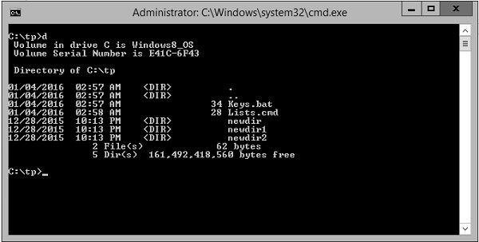

Deleting an Alias
An alias or macro can be deleted by setting the value of the macro to NULL.

Example
@echo off
doskey cd = cd/test
doskey d = dir
d=
In the above example, we are first setting the macro d to d = dir. After which we are setting it to NULL. Because we have set the value of d to NULL, the macro d will deleted.

Replacing an Alias
An alias or macro can be replaced by setting the value of the macro to the new desired value.

Example
@echo off
doskey cd = cd/test
doskey d = dir

d = dir /w
In the above example, we are first setting the macro d to d = dir. After which we are setting it to dir /w. Since we have set the value of d to a new value, the alias ‘d’ will now take on the new value.

Batch Script - Devices
Windows now has an improved library which can be used in Batch Script for working with devices attached to the system. This is known as the device console – DevCon.exe.
Windows driver developers and testers can use DevCon to verify that a driver is installed and configured correctly, including the proper INF files, driver stack, driver files, and driver package. You can also use the DevCon commands enable,disable,install,start,stop,andcontinue
in scripts to test the driver. DevCon is a command-line tool that performs device management functions on local computers and remote computers.
Display driver and device info DevCon can display the following properties of drivers and devices on local computers, and remote computers runningWindowsXPandearlier
−
- Hardware IDs, compatible IDs, and device instance IDs. These identifiers are described in detail in device identification strings.
- Device setup classes.
- The devices in a device setup class.
- INF files and device driver files.
- Details of driver packages.
- Hardware resources.
- Device status.
- Expected driver stack.
- Third-party driver packages in the driver store.
- Search for devices DevCon can search for installed and uninstalled devices on a local or remote computer by hardware ID, device instance ID, or device setup class.
- Change device settings DevCon can change the status or configuration of Plug and Play PnP
devices on the local computer in the following ways −
- Enable a device.
- Disable a device.
- Update drivers interactiveandnon−interactive
- .
- Install a device createadevnodeandinstallsoftware
  - .
  - Remove a device from the device tree and delete its device stack.
  - Rescan for Plug and Play devices.
  - Add, delete, and reorder the hardware IDs of root-enumerated devices.
  - Change the upper and lower filter drivers for a device setup class.
  - Add and delete third-party driver packages from the driver store.
DevCon DevCon.exe
is included when you install the WDK, Visual Studio, and the Windows SDK for desktop apps. DevCon.exe kit is available in the following locations when installed.
%WindowsSdkDir%\tools\x64\devcon.exe
%WindowsSdkDir%\tools\x86\devcon.exe
%WindowsSdkDir%\tools\arm\devcon.exe

Syntax
devcon [/m:\\computer] [/r] command [arguments]
wherein
- /m:\\computer − Runs the command on the specified remote computer. The backslashes are required.
- /r − Conditional reboot. Reboots the system after completing an operation only if a reboot is required to make a change effective.
- command − Specifies a DevCon command.
- To list and display information about devices on the computer, use the following commands −
  - DevCon HwIDs
  - DevCon Classes
  - DevCon ListClass
  - DevCon DriverFiles
  - DevCon DriverNodes
  - DevCon Resources
  - DevCon Stack
  - DevCon Status
  - DevCon Dp_enum
- To search for information about devices on the computer, use the following commands −
  - DevCon Find
  - DevCon FindAll
- To manipulate the device or change its configuration, use the following commands −
  - DevCon Enable
  - DevCon Disable
  - DevCon Update
  - DevCon UpdateNI
  - DevCon Install
  - DevCon Remove
  - DevCon Rescan
  - DevCon Restart
  - DevCon Reboot
  - DevCon SetHwID
  - DevCon ClassFilter
  - DevCon Dp_add
  - DevCon Dp_delete

Examples
Following are some examples on how the DevCon command is used.
List all driver files
The following command uses the DevCon DriverFiles operation to list the file names of drivers that devices on the system use. The command uses the wildcard character ∗
to indicate all devices on the system. Because the output is extensive, the command uses the redirection character >
to redirect the output to a reference file, driverfiles.txt.
devcon driverfiles * > driverfiles.txt
The following command uses the DevCon status operation to find the status of all devices on the local computer. It then saves the status in the status.txt file for logging or later review. The command uses the wildcard character ∗
to represent all devices and the redirection character >
to redirect the output to the status.txt file.
devcon status * > status.txt
The following command enables all printer devices on the computer by specifying the Printer setup class in a DevCon Enable command. The command includes the /r parameter, which reboots the system if it is necessary to make the enabling effective.
devcon /r enable = Printer
The following command uses the DevCon Install operation to install a keyboard device on the local computer. The command includes the full path to the INF file for the device keyboard.inf
and a hardware ID ∗PNP030b
.
devcon /r install c:\windows\inf\keyboard.inf *PNP030b
The following command will scan the computer for new devices.
devcon scan
The following command will rescan the computer for new devices.
devcon rescan

Batch Script - Registry
The Registry is one of the key elements on a windows system. It contains a lot of information on various aspects of the operating system. Almost all applications installed on a windows system interact with the registry in some form or the other.
The Registry contains two basic elements: keys and values. Registry keys are container objects similar to folders. Registry values are non-container objects similar to files. Keys may contain values or further keys. Keys are referenced with a syntax similar to Windows' path names, using backslashes to indicate levels of hierarchy.
This chapter looks at various functions such as querying values, adding, deleting and editing values from the registry.
S.No | Types of Registry & Description
1 | Reading from the Registry  Reading from the registry is done via the REG QUERY command.
2 | Adding to the Registry  Adding to the registry is done via the REG ADD command.
3 | Deleting from the Registry  Deleting from the registry is done via the REG DEL command.
4 | Copying Registry Keys  Copying from the registry is done via the REG COPY command.
5 | Comparing Registry Keys  Comparing registry keys is done via the REG COMPARE command.

Batch Script - Network
Batch script has the facility to work with network settings. The NET command is used to update, fix, or view the network or network settings. This chapter looks at the different options available for the net command.
S.No | NET Commands & Description
1 | NET ACCOUNTS  View the current password & logon restrictions for the computer.
2 | NET CONFIG  Displays your current server or workgroup settings.
3 | NET COMPUTER  Adds or removes a computer attached to the windows domain controller.
4 | NET USER  This command can be used for the following  View the details of a particular user account.
5 | NET STOP/START  This command is used to stop and start a particular service.
6 | NET STATISTICS  Display network statistics of the workstation or server.
7 | NET USE  Connects or disconnects your computer from a shared resource or displays information about your connections.

Batch Script - Printing
Printing can also be controlled from within Batch Script via the NET PRINT command.

Syntax
PRINT [/D:device] [[drive:][path]filename[...]]
Where /D:device - Specifies a print device.

Example
print c:\example.txt /c /d:lpt1
The above command will print the example.txt file to the parallel port lpt1.

Command Line Printer Control
As of Windows 2000, many, but not all, printer settings can be configured from Windows's command line using PRINTUI.DLL and RUNDLL32.EXE

Syntax
RUNDLL32.EXE PRINTUI.DLL,PrintUIEntry [ options ] [ @commandfile ]
Where some of the options available are the following −
- /dl − Delete local printer.
- /dn − Delete network printer connection.
- /dd − Delete printer driver.
- /e − Display printing preferences.
- /f[file] − Either inf file or output file.
- /F[file] − Location of an INF file that the INF file specified with /f may depend on.
- /ia − Install printer driver using inf file.
- /id − Install printer driver using add printer driver wizard.
- /if − Install printer using inf file.
- /ii − Install printer using add printer wizard with an inf file.
- /il − Install printer using add printer wizard.
- /in − Add network printer connection.
- /ip − Install printer using network printer installation wizard.
- /k − Print test page to specified printer, cannot be combined with command when installing a printer.
- /l[path] − Printer driver source path.
- /m[model] − Printer driver model name.
- /n[name] − Printer name.
- /o − Display printer queue view.
- /p − Display printer properties.
- /Ss − Store printer settings into a file.
- /Sr − Restore printer settings from a file.
- /y − Set printer as the default.
- /Xg − Get printer settings.
- /Xs − Set printer settings.

Testing if a Printer Exists
There can be cases wherein you might be connected to a network printer instead of a local printer. In such cases, it is always beneficial to check if a printer exists in the first place before printing.
The existence of a printer can be evaluated with the help of the RUNDLL32.EXE PRINTUI.DLL which is used to control most of the printer settings.

Example
SET PrinterName = Test Printer
SET file=%TEMP%\Prt.txt
RUNDLL32.EXE PRINTUI.DLL,PrintUIEntry /Xg /n "%PrinterName%" /f "%file%" /q

IF EXIST "%file%" (
ECHO %PrinterName% printer exists
) ELSE (
ECHO %PrinterName% printer does NOT exists
)
The above command will do the following −
- It will first set the printer name and set a file name which will hold the settings of the printer.
- The RUNDLL32.EXE PRINTUI.DLL commands will be used to check if the printer actually exists by sending the configuration settings of the file to the file Prt.txt

Batch Script - Debugging
Very often than not you can run into problems when running batch files and most often than not you would need to debug your batch files in some way or the other to determine the issue with the batch file itself. Following are some of the techniques that can help in debugging Batch Script files.

Error Messages
To discover the source of the message, follow these steps −
Step 1 − REM out the @ECHO OFF line, i.e. REM @ECHO OFF or :: @ECHO OFF.
Step 2 − Run the batch file with the required command line parameters, redirecting all output to a log file for later comparison.
test.bat > batch.log 2>&1
Step 3 − Search the file batch.log for the error messages
Step 4 − Check the previous line for any unexpected or invalid command, command line switches
or values
; pay special attention to the values of any environment variables used in the command.
Step 5 − Correct the error and repeat this process until all error messages have disappeared.

Complex Command Lines
Another common source of errors are incorrectly redirected commands, like for example "nested" FIND or FINDSTR commands with incorrect search strings, sometimes within a FOR /F loop.
To check the validity of these complex commands, follow these steps −
Step 1 − Insert "command check lines" just before a line which uses the complex command set.
Following is an example wherein the ECHO command is inserted to mark where the output of the first TYPE command ends and the next one starts.
TYPE %Temp%.\apipaorg.reg
ECHO.================================================ TYPE %Temp%.\apipaorg.reg
| FIND
"[HKEY_LOCAL_MACHINE\System\CurrentControlSet\Services\TCPIP\Parameters\Interfaces\"
Step 2 − Follow the procedure to find error message sources described above.
Step 3 − Pay special attention to the output of the "simplified" command lines: Is the output of the expected format? Is the "token" value or position as expected?

Subroutines
Subroutines generating error messages pose an extra "challenge" in finding the cause of the error, as they may be called multiple times in the same batch file.
To help find out what causes the incorrect call to the subroutine, follow these steps −
Step 1 − Add and reset a counter variable at the beginning of the script −
SET Counter = 0
Step 2 − Increment the counter each time the subroutine is called, by inserting the following line at the beginning of the subroutine
SET /A Counter+=1
Step 3 − Insert another line right after the counter increment, containing only the SET command; this will list all environment variables and their values.
Step 4 − Follow the procedure to find error message sources described above.

Windows Versions
If you intend to distribute your batch files to other computers that may or may not run the same Windows version, you will need to test your batch files in as many Windows versions as possible.
The following example shows how to check for various operating system versions to check the relevant windows versions.
@ECHO OFF
:: Check for Windows NT 4 and later

IF NOT "%OS%"=="Windows_NT" GOTO DontRun
:: Check for Windows NT 4
VER | FIND "Windows NT" >NUL && GOTO DontRun
:: Check for Windows 2000
VER | FIND "Windows 2000" >NUL && GOTO DontRun
:: Place actual code here . . .
:: End of actual code . . .
EXIT

:DontRun
ECHO Sorry, this batch file was written for Windows XP and later versions only

Batch Script - Logging
Logging in is possible in Batch Script by using the redirection command.

Syntax
test.bat > testlog.txt 2> testerrors.txt

Example
Create a file called test.bat and enter the following command in the file.
net statistics /Server
The above command has an error because the option to the net statistics command is given in the wrong way.

Output
If the command with the above test.bat file is run as
test.bat > testlog.txt 2> testerrors.txt
And you open the file testerrors.txt, you will see the following error.
The option /SERVER is unknown.
The syntax of this command is −
NET STATISTICS
[WORKSTATION | SERVER]
More help is available by typing NET HELPMSG 3506.
If you open the file called testlog.txt, it will show you a log of what commands were executed.
C:\tp>net statistics /Server

Batch file commands

In this tutorial, you will learn about batch file commands and how they are used in batch file scripting or programming.

As discussed in the previous tutorial, a batch file is an unformatted text file or script file which contains multiple batch file commands or instructions to achieve a certain task. It has extension of .bat or .cmd.
Click here to go through the introduction of the batch file before learning batch file commands.

Batch file commands: Windows/DOS
For the ease of learning, we have listed all the batch file commands with relevant examples and explanations below. Please click on the commands to know the details.

List of batch file commands
ASSOC | ATTRIB | CD | CHKDSK | CHOICE
CLS | CMD | COMP | CONVERT | COPY
DATE | DEL | DIR | DISKPART | DRIVERQUERY
ECHO | EXIT | EXPAND | FC | FIND
FORMAT | HELP | IPCONFIG | LABEL | MD
MORE | MOVE | NET | PAUSE | PING
RD | REM | REN | SET | SHUTDOWN
SORT | START | SYSTEMINFO | TASKKILL | TASKLIST
TIME | TITLE | TREE | TYPE | VER
VOL | XCOPY

Note: Batch file commands are not case sensitive

ASSOC

The batch command ASSOC associates a file extension with a file type, or list all associations.
Example
@echo OFF
ASSOC | find ".txt"
pause
Output
.txt = textfile
As shown in above output, it displays the file association for .txt extension.
If only ASSOC is written and executed, it will display all the file associations for every extension, instead of just .txt extension.

ATTRIB

The batch command ATTRIB is used to display the file attributes or set an attribute to a file in the working directory.
Example
Now let us suppose we have a file note.txt in our working directory. We will display its file attributes and then make it hidden and read only by adding 'ah' and 'r' attributes to it. And finally, we will remove some attributes we added as well.
@echo OFF
:: To display attribute of note.txt
ATTRIB note.txt

:: To make it read only by adding 'r'
ATTRIB +r note.txt
ATTRIB note.txt

:: To make it hidden by adding 'ah'
ATTRIB +ah note.txt
ATTRIB note.txt

:: To remove attribute read only
ATTRIB -r note.txt
ATTRIB note.txt
Output
A note.txt
A R note.txt
A R AH note.txt
A AH note.txt
Here in this output, A means Archived, R means Read only and AH means Hidden file.

CD

The batch command CD helps in navigating through different directories and changing directories or displaying current directory.
Example
@echo OFF
:: CD without any parameters displays the current working directory
CD
:: Changing to the parent directory one level up
CD..
CD
:: Changing the path to Programs
CD\Programs
CD
pause
Output
C:\Users\abc
C:\Users
C:\Programs

CHKDSK

The batch command CHKDSK is used for checking error in the disk.
Example
@echo OFF
CHKDSK

CHOICE

The batch command CHOICE provides a list of options to the user.
Example
@echo OFF
ECHO You want coffee?
ECHO Enter Y for yes
ECHO Enter N for no
CHOICE /c YN /m "Yes or No"
Output
Now that script will produce following output.
You want coffee?
Enter Y for yes
Enter N for no
Yes or No [Y,N]?
Now the console waits for your input and once you enter your answer it will terminate.

CLS

The batch command CLS clears the screen.
Example
@echo OFF
CLS
pause
This command just clears all the logs in command prompt screen.

CMD

The batch command CMD invokes a new command prompt window.
Example
@echo OFF
CMD

COMP

The batch command COMP compares the size of two files and checks if they are different in size.
Example
@echo OFF
COMP C:\abc.txt C:\xyz.txt

CONVERT

The batch command CONVERTS the volumes or drives from one format to another i.e from FAT to NTFS.
Example
@echo OFF
CONVERT D:\

COPY

The batch command COPY is used for copying files from one location to another.
Example
@echo OFF
:: For copying from one drive to another -xyz.txt from D:\ to E:\
COPY D:\xyz.txt E:\

:: If file has whitepace between name - use double quote
COPY "D:\my file.txt" E:\

DATE

The batch command DATE displays the current date in the system.
Example
@echo OFF
echo %DATE%
Output
Fri 07/07/2017
This command DATE displays system date in command prompt as shown above.

DEL

The batch command DEL is used for deleting files.
Example
@echo OFF
:: To delete a single file xyz.txt
DEL D:\xyz.txt

:: To delete all the files of .txt extensions and ask for confirmation before deleting
DEL /p/s D:\*.txt

:: Remove \p to delete without confirmation
DEL /s D:\*.txt
Note: DEL command only deletes files, not directories.

DIR

The batch command DIR lists all the contents of directories.
Example
@echo OFF
:: To list all the contents of current directory
DIR

:: To list all the hidden files of working directory
DIR /ah

:: To list all files with .php extensions
DIR *.php

DISKPART

The batch command DISKPART shows the properties of a disk partition.
Example
@echo OFF
DISKPART
This script will ask for users permission to check the properties of disk partition and if allowed, will display following output in the console depending on disk properties.
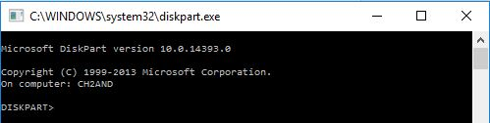

DRIVERQUERY

The batch command DRIVERQUERY displays all the drivers installed and their properties.
Example
@echo OFF
DRIVERQUERY
Output
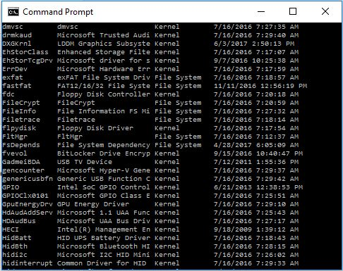
This output shows the fraction of drivers list with their properties and installed date. DRIVERQUERY command shows all the drivers list, which is huge.

ECHO

The batch command ECHO is used for echoing commands on/off and printing message to the console.
Example
@echo OFF
echo Hello
Output
Hello
This command ECHO displays Hello in the console as shown above.
Besides printing message, echo is also used for deciding whether or not to display the command itself. Like in this example as well, in the first line we have turned OFF echo, which makes sure that commands themselves are not printed.
If that echo wasn’t turned off, then the output would have been like:
C:\> echo Hello
Hello

EXIT

The batch command EXIT terminates and exits the console.
Example
@echo OFF
echo HI
EXIT
In this example, as soon as HI is printed in the console, EXIT command will terminate the program and close the output console.

EXPAND

The batch command EXPAND extracts the contents of .cab file.
Example
@echo OFF
EXPAND xyz.cab
This script will extract all the contents of xyz.cab file to the same location where xyz.cab is located.

FC

The batch command FC finds the difference between the two files and displays them to console.
Example
@echo OFF
FC D:\a.txt D:\b.txt
This script will find the difference in the content of both files and list out all of them.

FIND

The batch command FIND search the given file to find the desired string and if located, it displays the corresponding line in which the string exists.
Example
@echo OFF
FIND "find me" example.txt
This script will search for the string “find me” in example.txt file and if it exists in example.txt, it will display the corresponding line on the console.

FORMAT

The batch command FORMAT is used for formatting a drive of format FAT 16/32 or NTFS in Windows.
Example
@echo OFF
FORMAT E:\
This script will format E drive and overwrite previous contents.

HELP

This might be the one of the most important batch file commands because with this HELP command we can know about all the other commands used in batch file or command prompt.
Example
@echo OFF
HELP
Now this will display all the available commands with their functionalities in the console.
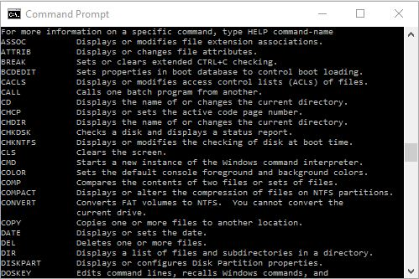
Since the list of commands is so much more, we have sliced the list and shown few here.
Now that we have a list of batch file commands, we can also view details of their syntax and functionalities in following way:
@echo OFF

:: Just type help and the command you want to know about
HELP copy
Now this will display details of the copy command.
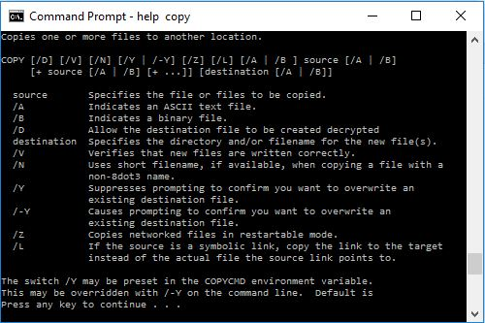
As you can see, it HELP COPY displays all the details about COPY command.

IPCONFIG

The batch command IPCONFIG displays Windows IP configuration.
Example
@echo OFF
IPCONFIG
This script will generate following output.
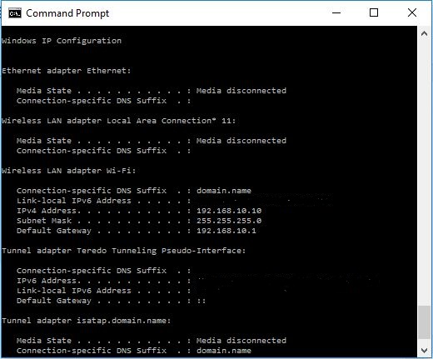
P.S: We have hidden iPV6 address in above output.

LABEL

The batch command LABEL displays the label of a drive or volume and is also is used for adding, setting or removing a disk label.
Example
@echo OFF
LABEL
Now this will display the label of your working directory and you can set, remove or add another label.
For example, my working directory is D: and has label ‘apps’. So, it will generate following output:
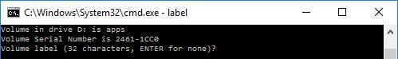

MD

The batch command MD creates a new directory or folder in the working directory.
Example
@echo OFF
MD abc
This program will create a new directory abc in current working location.

MORE

The batch command MORE displays the content of a file one by one.
Example
@echo OFF
MORE D:\example.txt
This program will display the contents of example.txt line by line, one at a time.

MOVE

This batch command moves files from one directory to another, rename the directories and move the directories as well.
Example
@echo OFF
:: To move xyz.txt from dir1 to dir2
MOVE C:\dir1\xyz.txt C:\dir2

:: To rename directory dir1 to dir2
MOVE C:\Program\dir1 C:\Program\dir2

:: To move directory dir1 from D:\ to D:\music
MOVE D:\dir1 D:\music\
In this way, MOVE command can be used to move files, directories and rename directories.

NET

The batch command NET is used for many network functionalities depending upon the commands used.
Example
To display the users:
@echo OFF
NET users
This will generate following output:
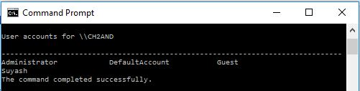
Like users, there are many other commands:
- net accounts
- net computer
- net config
- net continue
- net file
- net group
- net help
- net name
- net pause
- net print
- net send
- net session
- net share
- net start
- net statistics
- net stop
- net time
- net use
- net view

PATH

The batch command PATH displays the path variable or it can be used to set path variable.
Example
@echo OFF
ECHO %PATH%
This program will display the path of the current working directory.

PAUSE

The batch command PAUSE is used for holding the output screen till user enters a variable or a value.
Example
@echo OFF
ECHO hi
pause
This program will print hi in the console and show the message ‘Press any key to continue..’ and wait for the input from the user.

PING

The batch command PING is used for sending ICMP/IP packets to the designated address over the network.
Example
@echo OFF
PING 127.0.1.1
Output
This script will send packets to address 127.0.1.1 and output will be displayed as follows:
Pinging 127.0.1.1 with 32 bytes of data:
Reply from 127.0.1.1: bytes = 32 time<1ms TTL = 128
Reply from 127.0.1.1: bytes = 32 time<1ms TTL = 128

Ping statistics for 127.0.1.1:
Packets: Sent = 2, Received = 2, Lost = 0 (0% loss),
Approximate round trip times in milli-seconds:
Minimum = 0ms, Maximum = 0ms, Average = 0ms

RD

The batch command RD is used for removing the empty directories, directories with contents or files inside cannot be removed with RD command.
Example
@echo OFF
:: To remove directory xyz from C:\>
RD C:\xyz

:: To remove multiple directories from working location
RD dir1 dir2

REM

The batch command REM signifies comments in the batch script.
Example
@echo OFF
REM This is a comment
Anything written after REM is interpreted as a comment and is not executed in batch programs.

REN

The batch command REN is used for renaming files and directories.
Example
@echo OFF
:: To rename x.php to y.php
REN C:\x.php C:\y.php

SET

The batch command SET displays the list of environment variables of the system.
Example
@echo OFF
SET

SHUTDOWN

The batch command SHUTDOWN when invoked, shuts down the computer.
Example
@echo OFF
SHUTDOWN

SORT

The batch command SORT is used to sort the content of the file alphabetically.
Example
@echo OFF
SORT D:\example.txt
This script will sort the content of example.txt alphabetically either in ascending or descending order.

START

The batch command START is used to open a file or start a new program.
Example
@echo OFF
START paint.exe
This program will start the application paint if it is in the working location, else you will have to explicitly indicate the path of that program as well.

SYSTEMINFO

The batch command SYSTEMINFO displays all the configuration of the computer and operating system.
Example
@echo OFF
SYSTEMINFO
This will generate following output depending upon the computer:
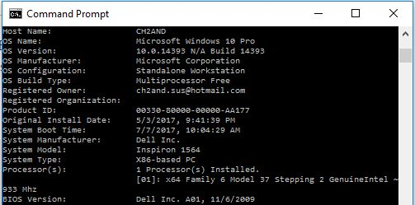
Of course, the details will be much more than this, but please try and look on your PC.

TASKKILL

The batch command TASKKILL is used to terminate a running task
Example
If you were to terminate the notepad running in your PC, then following script is used.
@echo OFF
TASKKILL /im notepad.exe

TASKLIST

The batch command TASKLIST lists all the running tasks in the console.
Example
@echo OFF
TASKLIST

TIME

The batch command TIME is used to display or set the system time.
Example
@echo OFF
ECHO %TIME%
Output
18:01:22:06
The current time is displayed in the console.

TITLE

The batch command TITLE sets new title for output console.
Example
@echo OFF
TITLE New Console
This script will set the title of output console to ‘New Console’. Thus the output console will look like:
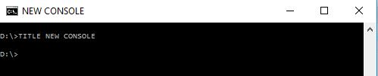

TREE

The batch command TREE displays the tree diagram of the subdirectories to the last level.
Example
I have a folder movies. SO, if I were to run TREE in that movie folder, it will create a tree of movies inside that folder and also the subdirectories where there is movie file and subtitle file.
@echo OFF
TREE D:\movies
Output
This script will generate following output.
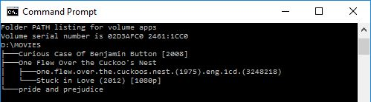

TYPE

The batch command TYPE is used for displaying the content of a file to an output console.
Example
@echo OFF
TYPE C:\notes.txt
pause
This program will display all the contents of notes.txt to the console.

VER

The batch command VER displays the version of Windows or MS-DOS.
Example
@echo OFF
VER
pause
Output
Microsoft Windows [Version 10.0.14393]

VOL

The batch command VOL displays the current volume label of Windows.
Example
@echo OFF
VOL
Output
Microsoft Windows [Version 10.0.14393]

XCOPY

The batch command XCOPY is similar to COPY command but COPY command copies single file whereas XCOPY command copies entire directories including subdirectories.
Example
@echo OFF
XCOPY D:\test.txt to E:\
This script will copy test.txt from D drive to E drive.

So, these are the batch file commands along with examples.
We hope you find these batch file commands easy to learn. We will discuss more advanced concepts in next tutorials.

Batch file variables

In this tutorial, you will learn about batch file variables and how they are used in batch file programming or scripting. You will also learn about the scope of variables in batch files.
Batch variables: Syntax
Batch variables: Example
Global variables vs Local variables
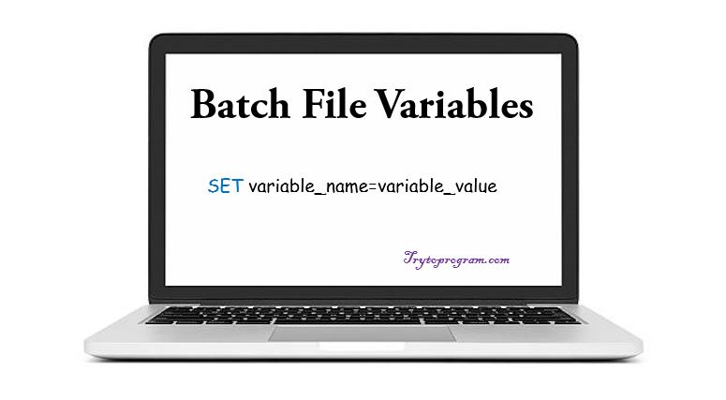
Batch file variables don’t need a declaration, in fact, the value is directly assigned to a variable using SET command.

Batch file variables – Syntax
Besides some reserved words (these predefined commands should not be used), any word or letter can be used as a variable.
Here is how the batch variables are declared.
SET varibale_name=variable_value

:: for assigning numeric value
SET /A variable_name=nameric_value
Note: DOS or Batch commands are not case sensitive and ‘/A’ is used for assigning numeric values. Uninitialized variables are empty strings in batch files.
Batch file variables: Things you must be aware of
Set command overwrites any existing variables. For example, dynamic variables like %DATE% , %TEMP%, %CD% and others seem so fancy that you ought to use these variables. But note that these dynamic variables act like commands in DOS and overwriting these variables can alter their meanings.
So it’s always better to verify you aren’t using any system variables. But how do verify it?

How to verify if batch variables are defined already?

Here is how we can check if a variable is defined or not in DOS.
IF DEFINED MyVar (ECHO MyVar IS defined) ELSE (ECHO MyVar is NOT defined)
Go through our batch files if else tutorial, if you are not familiar with the batch file if-else statements.

Batch file variables – Example
@echo OFF
SET name=Apple
ECHO %name%

:: For numberic variable
SET a=2
ECHO %a%
PAUSE
This script will generate following output:
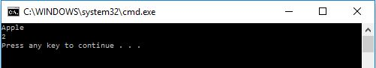
PAUSE is used to hold the screen until and it waits for user’s input.
Common Programming Error
Using whitespace between variable and value.SET name=Apple will work but SET name = Apple will not.

Now that you know how variables are used in batch file programs, let’s discuss global and local variables in batch files.

Variable scope in Batch files: Global variables and Local variables

As the name goes, global variable means a variable that can be accessed from anywhere in the program and local variable is the one that has limited scope or can be accessed from locally defined sections. By default, all the variables in batch file programs are GLOBAL.
Like any other programming language, Batch or DOS programming also has a definition for global and local variables.
As we mentioned, by default all the variables are global in a batch script, but they can be used as the local variable by using SETLOCAL command. Any variable assigned in between SETLOCAL and ENDLOCAL is taken as a local variable and its scope terminates and the variable is destroyed as soon as the ENDLOCAL statement is executed.
Following example will clear the concept of the local and global variable in batch file programming.
Example
@echo oFF
SET var1=var1 is global variable
SETLOCAL
SET var2=var2 is a local variable

ECHO %var1%
ECHO %var2%
ENDLOCAL
PAUSE
This will generate following output:
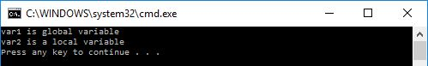
So it works in a cool way.
Now let’s see what happens when we try to use a local variable beyond its scope i.e using after ENDLOCAL.
Example
@echo oFF
SET var1=var1 is global variable
SETLOCAL
SET var2=var2 is a local variable

ECHO %var1%
ENDLOCAL
ECHO %var2%
PAUSE
In this program, var2 is a local variable and when we try to access it after ENDLOCAL is executed, the following happens.
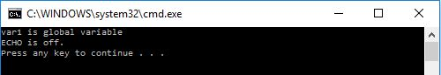
So as seen in this output, when we try to use local variable beyond its scope, instead of executing commands with the local variable, the ECHO is turned off.

Batch file if else

In this tutorial, you will learn about decision making structures that are the batch file if else statements.
If else statement: Introduction
If else statement syntax
Batch if else examples

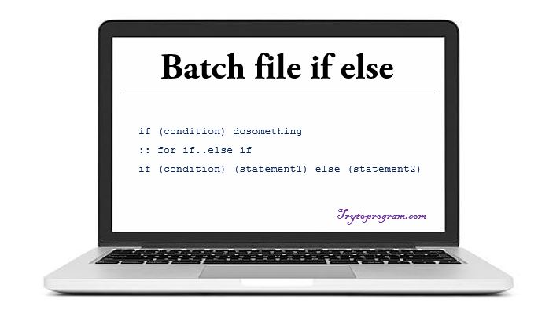
Basically programming logic is all about True (1) or False (0). Like any other programming language, batch file if else statements facilitate us to make a decision between true/false or multiple options by imposing a particular condition.

Batch file if else statement
– Syntax
if (condition) dosomething

:: For if..else if
if (condition) (statement1) else (statement2)
So, as the syntax signifies, first a condition is checked and if true, the corresponding statements are executed in the batch file if statement. As for batch file if else, first a condition of if statement is checked and if true, the statement1 is executed else statement2 is executed.

Batch File If Else Flowchart
Here is a flowchart to highlight the concept of if else statement.
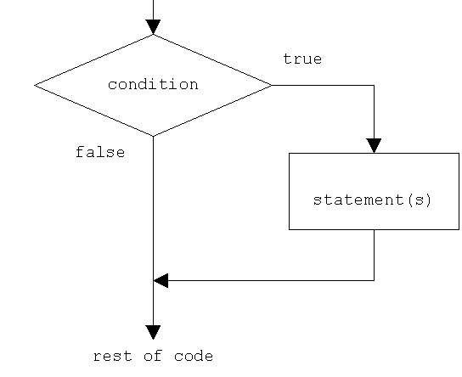
Now that we have known about how batch file if else works, let’s go through some examples.

Batch File If Else Example: Checking Integer Variables And String Variables
To know in depth and details about batch file variables, go through this article.
SET /A a=2
SET /A b=3
SET name1=Aston
SET name2=Martin

:: Using if statement
IF %a%==2 echo The value of a is 2
IF %name2%==Martin echo Hi this is Martin

:: Using if else statements
IF %a%==%b% (echo Numbers are equal) ELSE (echo Numbers are different)
IF %name1%==%name2% (echo Name is Same) ELSE (echo Name is different)
PAUSE
Now this will generate following output.
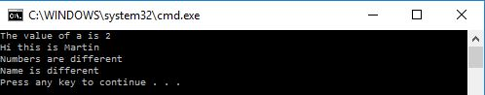

Batch File If Else Example To Check If Variable Is Defined Or Not
@echo OFF

::If var is not defined SET var = hello
IF "%var%"=="" (SET var=Hello)

:: This can be done in this way as well
IF NOT DEFINED var (SET var=Hello)
Either way, it will set var to 'Hello' as it is not defined previously.

Batch File If Else Example To Check If A File Or Folder Exists
EXIST command is used to check if a file exists or not. Read this article to know details of EXIST and all the other batch file commands.
@echo OFF

::EXIST command is used to check for existence
IF EXIST D:\abc.txt ECHO abc.txt found
IF EXIST D:\xyz.txt (ECHO xyz.txt found) ELSE (ECHO xyz.txt not found)

PAUSE
Now, let’s assume we have "abc.txt" in D drive and "xyz.txt" doesn’t exist in D: , then it will generate following output.
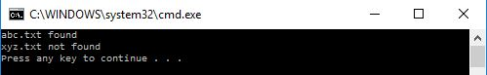
So, that’s all about batch file if else statements. We hope you didn’t have a hard time learning about it and hopefully, by this time, you will know how to use if else in batch file scripting.

Batch file for loop

In this tutorial, you will learn about the batch file for loop. Likewise if else statements, loops are also used to alter the flow of program’s logic.
For loop syntax
For loop example
Looping through a range
Looping through files
Looping through directories
Looping basically means going through something continuously until some condition is satisfied.
In batch files, there is the direct implementation of for loop only. There does not exist while and do while loops as in other programming languages.

Batch File For Loop Syntax
FOR %%var_name IN list DO example_code
Here, the list is the values for which for loop will be executed. One thing to be noticed in batch file for loops is that, variable declaration is done with %%var_name instead of %var_name%.
Let’s take an example for illustrating batch file for loop.

Batch file for loop example
@echo OFF
FOR %%x IN (1 2 3) DO ECHO %%x
PAUSE
Here in this program, we have 1, 2 and 3 in the list. So, for every element of the list the for loop will be executed and following output is generated.
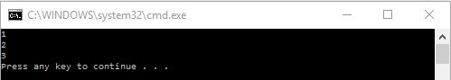
Now that we know about the simple implementation of for loop, let’s implement for loop to next level.

Batch file for loop – looping through a range of values
In batch file programming, for loop can also be implemented through a range of values. Following is the syntax for implementing for loop through a range of values in the batch file.
FOR /L %%var_name IN (Lowerlimit, Increment, Upperlimit) Do some_code
Where,
- /L signifies that for loop is used for iterating through a range of values
- Lower limit is the value from which loop will start until it reaches the Upper limit and the increment is the value with which lower limit will be increased during each iteration
The following example will highlight its concept in more details.
@echo OFF
FOR /L %%y IN (0, 1, 3) DO ECHO %%y
PAUSE
Now, this program will go through range 0 to 3, incrementing the value by 1 in each iteration.
Output
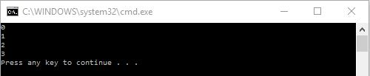

Batch file for loop – looping through files
So far in for loop, we have used ‘%%’ followed by a single letter. But to loop through files using for loop, we have to use ‘%’ followed by a single letter like %y.
So here is the syntax or perhaps an example of for loop for looping through files in particular location.
FOR %y IN (D:\movie\*) DO @ECHO %y
This will go through all the files in movie folder of D: and display the files in output console.

Batch file for loop – looping through directories
For looping through directories, ‘/D/ is used. It is illustrated in the following example.
FOR /D %y IN (D:\movie\*) DO @ECHO %y
Now this will go through even the sub-directories inside movie folder if there exist any.
So, this is all about the batch file for loops. Please practice every piece of code on your local machine for effective learning.

Batch file return code

In this tutorial, you will learn about batch file return code, what is a return code and how is it used in batch file programming.
Batch files return code: Introduction
Error level in batch file
Batch files return code: Example



Batch file return code – Introduction

So, a return code is a code returned after the execution of a program. By default, the command line execution should return zero when execution succeeds and non-zero when execution fails. When execution fails, the returned non-zero value indicates the corresponding error number and user can go through that error to resolve it.
These returned error codes are also called exit codes. Almost all application or utilities return the exit code when they are complete or they terminate.
Following are some of the non-zero numbers (exit codes) returned from programs with their corresponding errors.
Exit Code/Error Code | Details/Description
0 | Program successfully executed.
1 | Incorrect function. Indicates that Action has attempted to execute non-recognized command in Windows command prompt cmd.exe.
2 | Indicates that the system cannot find the file in that specified location.
3 | Indicates that the system cannot find the specified path.
5 | Access is denied. So the user has no access right to specified resource.
9009  0x2331 | Program is not recognized as an internal or external command, operable program or batch file. Indicates that command, application name or path has been misspelled when configuring the Action.
3221225477  0xC0000005  -1073741819 | Access violation.  Indicates that the executed program has terminated abnormally or crashed.
3221225495  0xC0000017  -1073741801 | Not enough virtual memory is available.  Indicates that Windows has run out of memory.
3221225786  0xC000013A  -1073741510 | The application terminated as a result of a CTRL+C. Indicates that the application has been terminated either by user’s keyboard input CTRL+C or CTRL+Break or closing command prompt window.
3221225794  0xC0000142  -1073741502 | The application failed to initialize properly. Indicates that the application has been launched on a Desktop to which current user has no access rights. Another possible cause is that either gdi32.dll or user32.dll has failed to initialize.
221225495  0xC0000017  -1073741801 | Not enough virtual memory is available.  It indicates that Windows has run out of memory.
3221226505  0xC0000409  -1073740791 | Stack buffer overflow / overrun. Error can indicate a bug in the executed software that causes stack overflow, leading to abnormal termination of the software.
3762507597  0xE0434F4D  -532459699 | Unhandled exception in .NET application. More details may be available in Windows Event log.
Now that we know about exit codes, the next thing is to know or check the return codes in our script commands. For that, environment variable %ERRORLEVEL% is used.

Error Level In Batch File

The environmental variable %ERRORLEVEL% contains the return code or the latest error level in the batch file, which is the latest error codes from the last command executed.
A common way of checking Error levels using %ERRORLEVEL% variable is:
IF %ERRORLEVEL% NEQ 0 Echo An error was found
IF %ERRORLEVEL% EQU 0 Echo No error found
Besides this, the command EXIT /B %ERRORLEVEL% at the end of the batch file also returns the error codes from the batch file.
EXIT /B < exitcodes > is used to return custom return codes.

Batch file return code example

Here is a simple example to illustrate how to check error codes in a batch file.
IF EXIST D:/abc.txt EXIT 9
EXIT 0
So, basically what this script does is, it checks D: for file abc.txt. If the file exist, it will return error code zero and terminate and if the file abc.txt doesn’t exist in D: , then it will return error code 9 and terminate.

Batch file functions

In this tutorial, you will learn about batch file functions and how functions are written in batch file programs.
Batch script functions: Introduction
Function definition
Function call
Basic function example
Function with parameters
Function with return values

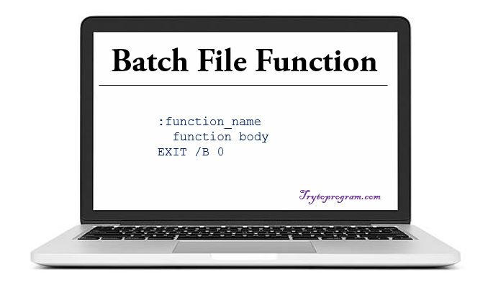

Batch file functions: Introduction

A function is a single comprehensive unit (self-contained block) containing a block of code that performs a specific task. The function performs the same task when called which avoids the need of rewriting the same code again and again.
Like in any other programming language, batch file functions also have:
- function definition
- function call
NOTE: When defining the main program is to ensure that the statement EXIT /B %ERRORLEVEL% is used in the main program to separate the code of the main program from the function.

Batch File Function Definition
-Syntax
:function_name
Some_Operational_Code
EXIT /B 0
As shown in syntax, a function definition in batch file starts with the declaration of a function with a label. Next is the body of function where we write codes to achieve a certain task. At the end EXIT /B 0 is to ensure successful termination or proper exit of the functions.

Batch File Functions Call

Like in every other programming language, to use the defined functions, we need to call it in the main program. For this, CALL command is used.
Learn more details about all batch file commands here.
-Syntax
:: To call function without parameters
CALL :function_name

:: To call function with parameters
CALL :function_name param1, param2,...,paramN

:: To call function with return values
CALL :function_name return_value1,return_value2,..,return_valueN
So, this is how the function is called in batch files.
In the case of batch file functions with parameters, a tilde(~) sign is used to access them in the main program along with the positional number of parameter.
Similarly, in the case of batch file functions with return values, return values are set in the function using the set command and the tilde(~) character along with the positional number of the return values.
Here is the batch file program to demonstrate the use of the basic function, function with parameters and function with return values.

Batch file function example: Program with basic function
@echo OFF
CALL :basic_function
EXIT /B %ERRORLEVEL%
:basic_function
SET n=Harry
ECHO My name is %n%
PAUSE
EXIT /B 0
Output
Note that the EXIT /B %ERRORLEVEL% is used to separate the function from the main program and PAUSE is used to hold the screen, else output console will vanish within nanoseconds.
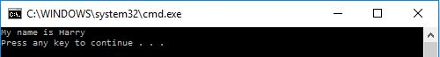

Batch file function example: Program demonstrating function with parameters
@echo OFF
CALL :param_function 20, 400
EXIT /B %ERRORLEVEL%
:param_function
ECHO The square of %~1 is %~2
PAUSE
EXIT /B 0
Output
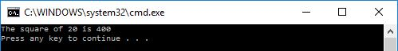
Here tilde(~) sign is used to access the parameter’s value followed by the position of the parameter. Hence, ~1 is for accessing first parameter and ~2 for the second.

Batch file function example: Program demonstrating function with return values
@echo OFF
CALL :retun_value_function ret_val1,ret_val2
ECHO The square root of %ret_val1% is %ret_val2%
PAUSE
EXIT /B %ERRORLEVEL%
:return_value_function
SET %~1=100
SET %~2=10
EXIT /B 0
Output
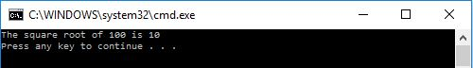
Here SET command along with tilde(~) sign is used to set the return values depending on the position followed by tilde sign.

Batch File Shutdown Commands – How To Shutdown, Reboot And Logoff

In this article, you will learn about different commands and ways to shut down, reboot, and log off the PC. You will learn about batch file shutdown commands in detail.
How to shutdown?
How to log off?
How to hibernate?
How to reboot?
Example: source code
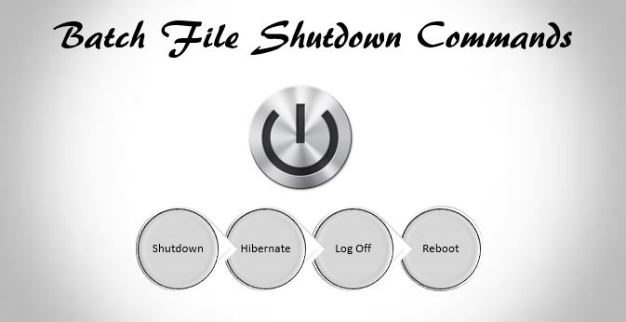

How to shutdown computer using cmd/batch file?

The command used to shut down computer is
shutdown /s /f /t 0

Shut down computer using cmd
Follow these steps to shut down the computer using cmd.
- Run the command prompt
- Type the above command and hit enter
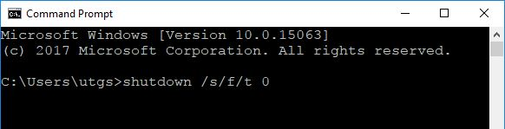
The computer will shut down immediately after hitting this command.

Shutdown computer using a batch file
Here are the steps to shut down a computer using a batch file.
- Open a notepad and click on new file
- Paste the shutdown code stated above and save the file as turn_off.bat
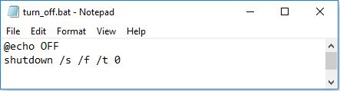
- Once you have saved the file, click on the .bat file and your computer will start shutting down.
Alternately the following code can be used for immediate shutdown.
SHUTDOWN /p

How to shutdown the computer by setting time using cmd/batch?
The code we stated above is used to shut down the computer immediately after hitting the code. We have to use the following command to set the timing for shutting down.
For example, the following code is used to shut down a computer in 60 seconds.
SHUTDOWN /s /t 60 /c

How to log off a computer using batch/cmd?

Logging off means signing out of from the current logged in account. Here is the code to log off or sign out.
SHUTDOWN /l
where l signifies shortcut command for logging off.

How to hibernate a computer using batch/cmd?

Hibernating is same as shutting down but when you hibernate your computer, it stores and remembers the previous state of the computer before hibernating and it will resume from there.
Here is the code to hibernate a computer.
SHUTDOWN /h

How to reboot a computer using batch/cmd?

Here is the code required to reboot a computer, be it from command prompt or batch file.
Here is the code to reboot a computer.
SHUTDOWN -r -t 10
This is the code to reboot the computer in 10 seconds.

Batch file program to shutdown, reboot, hibernate, and logoff the computer
Let’s take an example where the user will be asked to enter an option whether to logoff or reboot or hibernate or to shutdown the computer.
Here is the source code.
@echo OFF

ECHO "Choose an option .."
ECHO "1 = Logoff"
ECHO "2 = Reboot"
ECHO "3 = Hibernate"
ECHO "4 = Shutdown"

SET /p option=Choose one option-

IF %option%==1 SHUTDOWN /l
IF %option%==2 SHUTDOWN -r -t 10
IF %option%==3 SHUTDOWN /h
IF %option%==4 SHUTDOWN /s /f /t 0

PAUSE
Save this as .bat file and double click on it to run. The output console will be like the following.
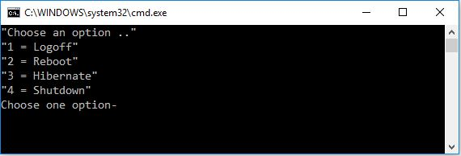
Now depending on the option you choose the computer will be either shut down, logoff, hibernate or reboot.

Batch file Network Commands: NET

In this tutorial, you will learn in depth about batch file network commands: NET with examples.
Batch file NET command: Introduction
NET USER command: Introduction
Adding new user account
Changing password of the user account
Deleting user account
Viewing information of user account
Assigning admin rights
Starting & Stopping services
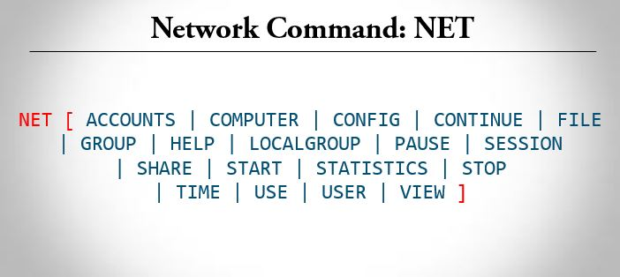
Batch file NET commands are used to manage and troubleshoot any aspect of the network with lot more exciting features.
For those who are not familiar with command line and batch file, we will guide you through every aspect of net command.

Batch file: NET command

We can use NET commands for managing our network as well as troubleshooting locally and remotely in any network.
There are 21 sub-commands with its own switches.
Don’t panic we will explain each and every command.
Syntax of net command:
NET [ACCOUNTS | COMPUTER | CONFIG | CONTINUE | FILE | GROUP |
HELP | LOCALGROUP | PAUSE | SESSION | SHARE | START |
STATISTICS | STOP | TIME | USE | USER | VIEW ]
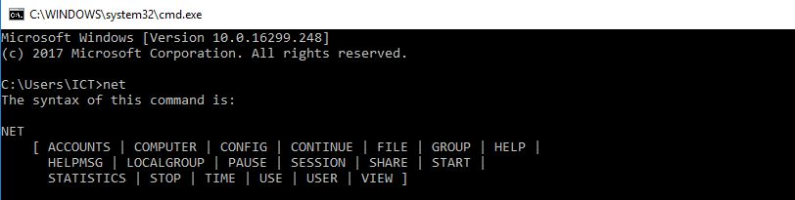
If you are new to this command, then NET HELP command explains different types of names and syntax of NET command as follow:
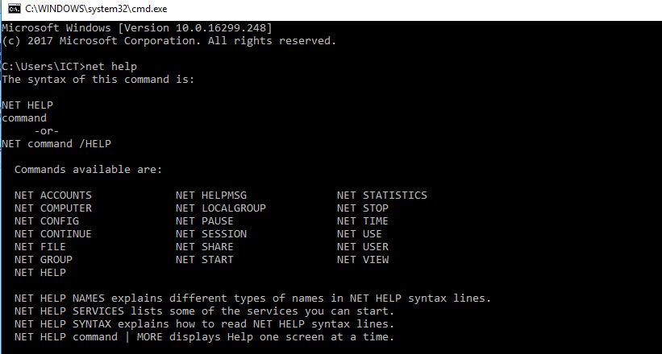
Now let’s take a look at one of the interesting NET subcommand i.e. USER

Batch file command: NET USER

NET USER command is used for viewing, creating, deleting and setting the password for an existing or newly created accounts in windows.
For this, we should run command line with administrative privileges.
Syntax of NET USER command:
C:\> NET USER
This command will display all the users in you local machine.
The NET command with USER or USERS will perform the same operation.
As seen in the above picture, there are five different users on my local machine i.e.
'Administrator', 'DefaultAccount', 'Guest', 'ICT' and WDAGUtilityAccount'
The Administrator and Guest are default accounts created when we install an operating system.
Administrator user has admin rights whereas Guest belongs to the same category with fewer privileges.
I created ICT account when installing windows.
Other accounts were created by the operating system for different purposes such as remote access, troubleshooting, and updates.

Adding the new user using a command line and Batch file.
So let’s have some fun using NET subcommand USER along with the '/add'.
C:\> NET USER "username" "password" /add
where,
username = new username you want to add
password = password for the new username
Let’s run the command:
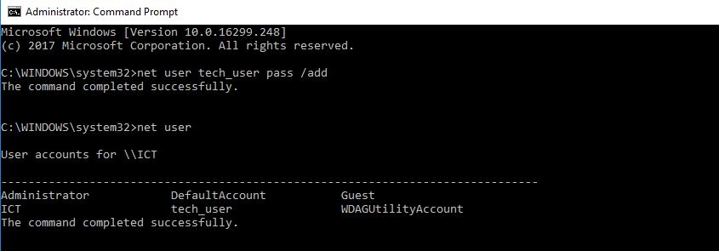
As we can see in the above picture, we have created a new account named tech_user with pass as a password.
This tech_user have normal privileges and restricted from installing new software and access to restricted folders.
This can be done using the batch file as follow:
@echo off
net user tech_user pass /add
Write the above code in notepad and save it with .bat extension. Run the saved file using administrator rights the new user will be created in your computer.

Changing password of the newly created account using command line

C:\> NET USER tech_user *
Type a password for the user:
Retype the password to confirm:
Type new password, confirm it and see the result.
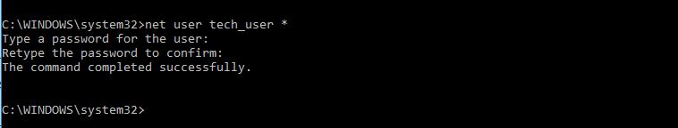
The above code will change the password.

Changing password of user account using batch file

@echo off
net user tech_user *
If you run this file, it will ask for new password.

Deleting user account using command line
We can also delete the user account using NET USER command with ‘/delete’.
Syntax
C:\> NET USER user_name /delete
Let’s run this syntax in command line
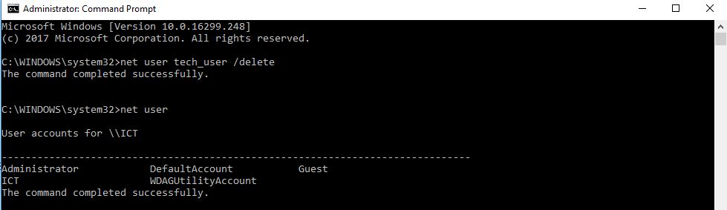
Now we can see that tech_user account has been successfully removed from the computer.

Batch file syntax for deleting user account
@echo off
net user tech_user /delete

What if you want to see detailed information about a specific user?
For this, we have following syntax
C:\> NET USER user_name
This command will display account information, password last set, password expiry, whether the user has right to change the password and other information.
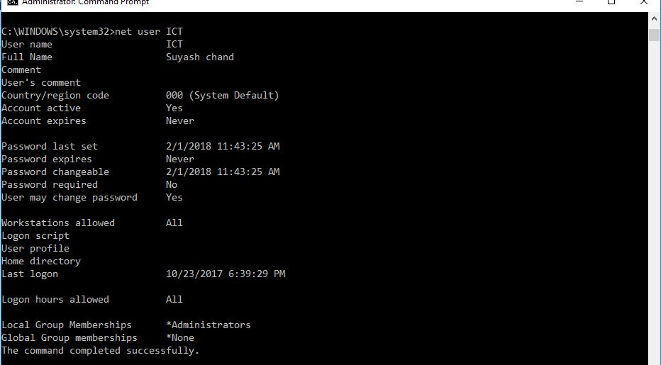

Assigning administrator rights to the user account
As said earlier, by default newly created account doesn’t have administrator privileges.
However, we can assign administrator rights to the accounts using the command line.
For this, we have to use localgroup subcommand.
C:\> net localgroup administrators tech_user /add
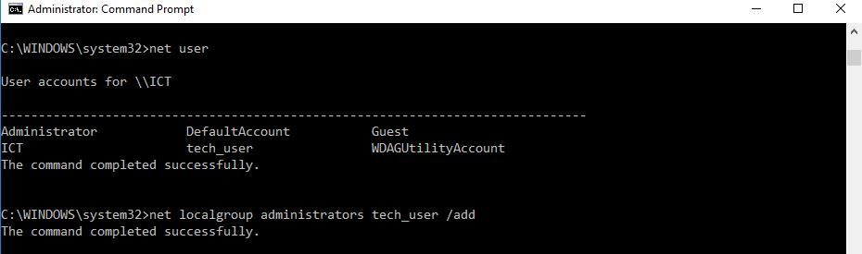
Now, I have assigned tech_user account to the administrator group which means it now has administrator privileges.
Again for deleting the user, we have to use the above mentioned /delete command.

Starting and stopping specific services supported by computer using the command line
There are various services running on the computer which can be viewed from services.msc.
Let’s try to start and then stop print spooler service using the command line.
Syntax
C:\> net start service_name
C:\> net stop service_name
where,
service_name = specific service name
Starting print spooler service
Stopping print spooler service
http://www.trytoprogram.com/batch-file

